ROADSAFENET:
AN OPEN-SOURCE AI AND IoT-ENABLED ROAD ACCIDENT DETECTION SYSTEM

WARNAKULASOORIYA FERNANDO SUSHEN ASHARA

A project report submitted in partial fulfilment of the requirements for the award of Bachelor of Information Technology (Hons)

School of Information Technology
SEGi University

DECLARATION

I hereby declare that this project report is based on my original work except for
citations and quotations which have been duly acknowledge. I also declare that it has
not been previously and concurrently submitted for any other degree or award at SEGI UNIVERSITY or other institutions.


Signature:
Name: WARNAKULASOORIYA FERNANDO SUSHEN ASHARA
ID No: SUKD2300644
Date: AUGEST 11,2025

APPROVAL FOR SUBMISSION

I certify that this project report entitled “ROADSAFENET: AN OPEN-SOURCE AI AND IoT-ENABLED ROAD ACCIDENT DETECTION SYSTEM” was prepared by WARNAKULASOORIYA FERNANDO SUSHEN ASHARA and has met the required standard for submission in partial fulfilment of the requirements for the award of Bachelor of Information Technology (Hons) at SEGi University.

Approved by:
Signature: ______________________
Supervisor: ______________________
Date: _________________

The copyright of this report belongs to the author under the terms of the copyright Act 1987 as qualified by Intellectual Property Policy of SEGi University. Due acknowledgement shall always be made of the use of any material contained in or derived from this report.

© Year, Warnakulasooriya Fernando Sushen Ashara. All rights reserved

ACKNOWLEDGEMENT

Thank you all in the completion of my project and I would like to take this opportunity to express my deep gratitude to all involved with my success.

First of all, I would like to thank my supervisor Ms. Hazlina Haron, who provided me with invaluable advice, critical comments, and constant support during the progress of this project. Her knowledge, constructive advice and support have played a central role in helping to determine the course and quality of this piece of work.

I also appreciate my peers and colleagues who contributed to the project due to their collaborative nature and positive advice which substantially contributed to developing the technical and analytical features of the project.

I would also like to express my sincere gratitude to my family and my friends who gave me constant support encouragement, patience, and understanding and that feeling inspired me to go through rough times in the research and development process.

Lastly, I would like to recognize all those people and organizations (directly or indirectly) whose help, resources, and expertise helped the successful implementation of this project.

ABSTRACT

RoadSafeNet project comes forward as a cost efficient, scalable and an inclusive web based platform conceived to improve global road safety standards by integrating open-source Artificial Intelligence (AI) and Internet of Things (IoT) technology. To fix the global plague of 1.19 million road traffic death every year dysfunction, RoadSafeNet is a union of the YOLOv10 deep learning neural network to detect accidents in real-time, the open source map data in a geographical location correctly OpenStreetMap and the Nominatim API as well as the multilingual emergency services alerts in English, Spanish, Arabic, Hindi, and Mandarin powered by the Transformers by Hugging Face. SQLite database and Prisma ORM are used to store and analyze the data of accidents, and such interactive dashboards are created in Flask, FastAPI, and Plotly Dash to promote evidence-guided traffic management. It is run on commodity hardware making use of the infrastructure that is already in place through CCTV, which lowers the cost and increases the ability to implement the system in both urban and rural environments with the additional benefit of appearing less intrusive to those concerned about civil liberties. The iterative design was directed by agile development methodology approach, which made it responsive to stakeholder input, as well as allowing it to be suitable in different contexts. A comparison with available solutions (eCall, OnStar, Apple Crash Detection, EmergEye) reveals that RoadSafeNet is very much more affordable and inclusive and hardware independent. Not only do such a platform help decrease emergency response time, increasing survival rates, but also supply actionable information to policymakers, which aligns with the WHO target to cut road traffic death rates in half by 2030, and contribute to the development of smart city safety solutions based on AI and the Internet of Things.

TABLE OF CONTENTS

CHAPTER 1 INTRODUCTION 12

1.1 Introduction 12
1.2 Problem Background 15
1.3 Problem Statement 17
1.4 Aims and Objectives 18
1.4.1 Project Aim 18
1.4.2 Project Objectives 19
1.5 Project Scope 19
1.6 Significance of the Project 21
1.7 Chapter Summary 23

CHAPTER 2 LITERATURE REVIEW 25

2.1 Introduction 25
2.2 Computer Vision-Based Accident Detection Systems 26
2.2.1 Deep Learning Revolution in Accident Detection 28
2.2.2 YOLO Framework and Real-Time Detection 30
2.2.3 Video-Based Data Integration 32
2.2.4 Challenges and Limitations 32
2.2.5 CCTV-Only Accident Detection Systems 34
2.2.6 Multilingual Notification Systems 35
2.3 Similar Existing System 36
2.3.1 eCall (European Union) 36
2.3.2 OnStar (General Motors, USA) 38
2.3.3 Apple Crash Detection (iPhone & Apple Watch) 39
1.3.4 EmergEye (UC Berkeley, USA) 41
2.4 Comparison between systems 42
2.5 Proposed Solution 44
2.6 Development Platform 45
2.6.1 Web Based 45
2.6.2 Mobile Based 46
2.6.3 Justification for Selection of Platform Selection 46
2.7 Chapter Summary 46

CHAPTER 3 METHODOLOGY, ANALYSIS AND DESIGN 49

3.1 Introduction 49
3.2 Proposed Methodology 50
3.3 System Analysis 58
3.3.1 Functional and Non-Functional Requirements 59
3.3.2 Use Case Diagram 61
3.3.3 Use Case Descriptions 63
3.4 System Design 70
3.4.1 Sequence Diagram 71
3.4.2 Class Diagram 72
3.5 Data Modeling 74
3.5.1 Data Dictionary 74
3.5.2 Entity Relationship Diagram 76
3.6 Proposed Story Board 78
3.7 Test Plan 95
3.8 Chapter Summary 99

REFERENCES 101

LIST OF TABLES

Table 1 Comparison table 40
Table 2 Functional Requirements 57
Table 3 Non-Functional Requirements 58
Table 4 Data Dictionary 73
Table 5 Essential Test Cases 93
Table 6 Test Environment and Resources 94
Table 7 Test Data Requirements 94
Table 8 Test Schedule 95
Table 9 Test Documentation Template 95

LIST OF FIGURES

Figure 1 eCall 33
Figure 2 OnStar 34
Figure 3 Apple crash detection 36
Figure 4 EmergEye 37
Figure 5 Agile Methodology 47
Figure 6 Use Case Diagram 58
Figure 7 Example of Formatting Method 68
Figure 8 Class Diagram 69
Figure 9 Entity Relationship Diagram 73
Figure 10 Log in 76
Figure 11 Log Out 76
Figure 12 Home Page 77
Figure 13 Incident Detail Page 80
Figure 14 Analytics Dashboard Page 82
Figure 15 Notification Management Page 84
Figure 16 User Management Page 86
Figure 17 System Logs Page 88
Figure 18 Settings / Preferences Page 90

INTRODUCTION

Introduction
Road traffic collision is one of the most significant global public health issues, as it kills about 1.19 million people annually and injures between 20 and 50 million individuals with non-fatal injuries annually, both in the developed and developing world (World Health Organization [WHO], 2023). These accidents have huge social and economic burdens amounting to about 3 % of gross domestic products (GDP) of every country and also resulting in a lot of emotional and physical trauma to surrounding communities (Peden et al., 2004). The necessity of rapid emergency treatment is very important; research has indicated that a one-minute delay in providing emergency care may reduce survival rates by as much as 60 % both in towns and in the countryside (Zanella et al., 2014). The use of artificial intelligence (AI) and the Internet of Things (IoT) in smart-city developments can present a valuable course of action, especially in 2025, since such strategies are innovative, scalable, and cost-effective in improving road safety (Batty, 2020). However, most of the safety systems available today face certain challenges like reliance on proprietary equipment, computational expenditures, low language coverage, and inadequate data analysis, which makes their implementation particularly challenging in low-resource areas and their implementation more complicated in front of various people around the globe (Aslam et al., 2024; Liu et al., 2020). To address these problems, the project presents the RoadSafeNet: a web-based application developed with open-source components of AI and IoT to facilitate in-time crash notification, multilingual emergency messages, and evidence-based safety measures, all of which are aligned with the WHO vision of reducing road traffic fatalities by 50 % by 2030 (WHO, 2023).

The RoadSafeNet is a student project that combines a pile of open-source technologies to create a low-cost, large-scale solution to urban road safety in cities around the world. To its core, the newest version of the You Only Look Once (YOLO) computer vision, version 10, reliably detects crashes, cars rolling over and breaking, with 94 percent accuracy within the confines of typical machine setup, such as an 8GB RAM Intel i5 processor (Ultralytics, 2025) which is too good to pass when considering the situation in territories with fewer access to technology. Then there is OpenStreetMap together with the Nominatim API: these two stakeholders label the locations of accidents with unparalleled precision and dump the latitudes, longitudes, and street addresses in a database where such data can be queried, and the information streamed to the hospitals, the ambulances, and the police stations in both the city as well as the countryside throughout the whole world (OpenStreetMap Foundation, 2025). As a means of ensuring that telegraphs across the board receive the message, the system sends out multilingual alerts using Telegram bots fueled by Hugging Face Transformers, like mBART, that support English, Spanish, Arabic, Hindi, and Mandarin-speaking users, linguistic diversity right out of the box (Liu et al., 2020).

RoadSafeNet is supported by SQLite/Prisma ORM to store and manipulate the data. The lightweight combination enables high performance with quick queries to effectively initiate geographic heat maps to indicate areas of risk as well as in driving the traffic-management decisions via the city planners, policy-makers, and researchers (Prisma, 2025). Behind it all is a convenient web front end, made using Flask, Fast API, and Plotly Dash. The configuration serves up interactive dashboards and statistical reports aka bar charts of the number of accidents over time, so stakeholders can dive into the numbers as soon as possible (Plotly, 2023). RoadSafeNet hits right with the key buzzword of a smart city: AI-enhanced safety and the ability to integrate it with post-object connectivity via the Internet of Things. Due to such synchronization of the timeline, the project comes with a template that can be duplicated in any part of the world (Batty,2020).

Comparing the proposed RoadSafeNet to other road-safety tools, it becomes possible to identify the places where it is quite distinctive. Even simple eCall, which is required in EU cars since 2018, sensors included in the car detect an accident, call the emergency, and transmit the exact location and accident severity information (European Commission, 2023). It is superb in connected vehicles, but only newer vehicles with special hardware are receiving it, multilingual notifications are few, and geographies that cannot afford to upgrade all their older vehicles, or have a sparse infrastructure, cannot get it. OnStar is a crash-tracking system launched by General Motors that monitors crashes via sensors (or the OnStar Guardian app, which applies to non-GM cars as well) (OnStar, 2025). So, with that said, its monthly subscription, which costs 15-39.99, is not so affordable, and the proprietary algorithms cannot be compared to open-source models, such as YOLOv10 (Consumer Reports, 2024). Included with iPhone 14+ and Apple Watch Series 8+, Apple Crash Detection applies the motion sensors and GPS to detect hard crashes and call emergency responders, subscription-free to anyone with the necessary hardware (Apple, 2025). Its reliance on Apple technologies and the inability to perform complex data analysis or multitasking limits its potential, though. An unfamiliar phone-based alternative, Emerg Eye charges to phone sensors to detect crashes and trigger emergency alerts and is truly integrated, but limited documentation, proprietary systems, and an unswervingly monolingual makeup deter the expansion to a global scale. RoadSafeNet on the other hand combines open-source technology, high survival rates, multi-language alerts, and strong analytics, providing us with an inexpensive, transparent, and scalable solution that avoids hardware lock-in, monthly subscription models, and language exclusion.

The road-safety platform, RoadSafeNet, is designed to reduce the time of emergency response, increase the survival rate, and provide insights based on data to give traffic-management teams feedback on where to implement their hard work. The analytics engine in the system identifies high-risk areas to which characteristics can then be addressed via upgrades in the roadway, traffic lights, or communications-oriented public-awareness campaigns (Perera & Jayawardena, 2024). The solution offered by RoadSafeNet is multilingual, which opens the platform to all people, in the crowded urban areas and also in the secluded settings (Gunasekaran & Fernando, 2023). Academically, the project contributes to the development of a discussion in the fields of AI and IoT by demonstrating how open-source solutions can be applied in real life and how they may form a framework that can be subsequently copied by a group of researchers and students (Perera et al., 2024). RoadSafeNet can be marketed as an opportunity to address the road-safety crisis surrounding the world, which is why it is an innovation ideally suited to the challenges of well-developed and developing countries alike (WHO, 2023; Batty, 2020). With a goal of affordability, scalability, and inclusivity, the platform is the new standard of road-safety technology, managing immediate emergencies and facilitating long-term safety planning.

Problem Background
Road safety crisis is one of the burning issues in the spheres of public health and life in our society: according to WHO, each year, 1.19 million people die because of road traffic crashes and at least 20-50 million people are injured (WHO, 2023). The incidences are the number one cause of death especially among young adults between the ages of 15-29 and they cost the economy a lot in terms of resources valued at 3 percent of the world's GDP per annum, that is about 1.8 trillion dollars (Peden et al., 2004). Road traffic accidents have multiple causes that include human error (distracted driving, speeding, DUI), environmental factors (poor condition of roads, lack of signage, and bad weather), and vehicle factors (mechanical issues or obsolete safety mechanisms). It is a dynamic system of interaction as urban congestions increase the delay involved in the response to an emergency and the lack of rural infrastructure restricts accessibility to speedy medical care (Scolese et al., 2020). The seriousness of the need to respond to these challenges is highlighted by the places in the key aspect of emergency response times when even a few minutes of delays mean a decrease of up to 6 percent of survival chances (Zanella et al., 2014).

In cities and the countryside there are different issues related to road safety. Urban cities have high levels of traffic density, complicated road structures, and numerous intersections, which increase the rates of accidents, with 60 percent of road accidents related to the cities (UN-Habitat, 2022). Traffic may slow down on the way to the attack site, where the situation study demonstrated that the mean response time in urban areas reaches 8-15 minutes compared to an ideal 4 minutes of response (Fasano et al., 2021). In the countryside, the existing problems are a scant provision of emergency services, a bad road network, and a lack of connectivity, which may drag out the time of response to 20-30 minutes and beyond (Scolese et al., 2020). Such variations create the importance of establishing new systems able to work with a variety of contexts and guarantee quick detection and notification despite the geographical or infrastructure limitations.

The technology innovation has uncovered a way of reducing the risk on the roads, and there are still big gaps. Most of the prevalent systems hinge on expensive hardware, e.g., high-resolution cameras or custom sensors that cannot be deployed in mass in resource-poor areas (Aslam et al., 2024). As an example, advanced driver-assistance systems (ADAS) usually imply the use of special sensors, which makes them fit only in a limited range of vehicles in old fleets or impoverished nations (Goodfellow et al., 2016). Deep learning models have high computing demands that usually operate on GPU-intensive operating systems, which further limits the scalability of such models in regions that lack technological developments (Chen et al., 2022). Language barrier is another common issue, as the majority of systems are not multilingual, so the non-English-speaking residents are left out, and inclusivity is lowered (Liu et al., 2020). Moreover, there are no remote and powerful data storage and analysis tools, which makes it impossible to create actionable information, e.g., determine areas of accidents or the best traffic, etc. (Prisma, 2025). To illustrate, the stakeholder cannot analyze patterns to take appropriate actions to enhance their infrastructure or formulate a policy without lightweight databases or visualization tools (Batty, 2020).

The worldwide programmers, including the WHO Decade of Action of Road Safety (2021 - 2030) stress the importance of innovations, cost-effective options, and scalable solutions to cause a 50% reduction in road traffic fatalities by 2030 (WHO, 2023). One of the 2025 smart city trends focuses on how AI and IoT could positively change the safety of cities, and how the open-source solutions provide a cheaper alternative to custom hardware and software (Batty, 2020). Nonetheless, the still missing regeneration of functioning systems able to unite real-time accidents, highly specific geolocation assistance, multilingual within no constraints, and complex segmentation and measurability of accreditation is a significant flaw. Urban living needs a high rate of rapid identification of dense traffic, whereas the rural environment is exposed to a dependable geolocation to reach remote emergency services (Scolese et al., 2020). To tackle such problems, it is necessary to have a system that uses open-source options to provide affordability, scalability, and access inclusivity and respond to emergencies as well as plan safety based on data analytics, both in the short and long term.

Problem Statement
The world road safety crisis that claims 1.19 million lives and causes 20-50 million injuries each year highlights the seriousness of the problem, demanding innovative technological solutions to speed up the emergency response time and address data-based interventions of road safety issues (WHO, 2023). The systems that are currently available are promising but limited in their proper functionality which provides them with relevance in a global context. An example is eCall, which is required in EU cars, and works by using sensors installed in the vehicle to report the crash to emergency services, whereas its reliance on exclusive hardware makes it impractical to be applied to older vehicles, as well as in areas with resource limitations (European Commission, 2023). OnStar offers crash detection and road assistance, but charges high service fees (i.e., monthly subscriptions cost between 15 and 39.99) from now can hardly be used by the masses due to the costs of service (OnStar, 2025). Apple Crash Detection is a subscription-free crash detection system available on iPhone 14+ and Apple Watch Series 8+, which can be detected via motion sensors and GPS, whereas its productized nature, as well as the inability of advanced analytics and support of multiple languages, restrain its expansion capabilities (Apple, 2025). But, the smartphone-based product of EmergEye only offers the crash alerts without supporting additional languages and being well documented, which limits its urgent use across the world (EmergEye, 2024). Their hardware is expensive to implement, they are not comprehensive enough to address all of the issues involved in road safety and are singularly incompatible with diverse populations (Aslam et al., 2024).

The above gaps are closed with the proposed RoadSafeNet, which creates a web-based framework based on open-source technologies and provides real-time accident detection, a geolocation based on a precise 2m, multilingual notifications, and enhanced data analysis. Compared to current solutions, the proposed RoadSafeNet (when presented with standard equipment) uses YOLOv10 to provide high-accuracy accident type (e.g., collision, overturned vehicle, stopped vehicle) detection at a low cost since it is highly accurate (Ultralytics, 2025). With the United States-based OpenStreetMap with Nominatim API, we can geo-locate the world, providing the location of accidents given emergency services (OpenStreetMap Foundation, 2025). Hugging Face Transformers (e.g., mBART) also make it possible to use multilingual notifications (including but not limited to English, Spanish, and Arabic) because they provide inclusivity (Liu et al., 2020). SQLite and Prisma ORM make data storage efficient to use in analytics that can entail detecting high-risk zones, whereas Flask and FastAPI in combination with Plotly Dash provide interactive visualizations targeting the stakeholders (Prisma, 2025; Plotly, 2023). With the focus on affordability and its scalability, as well as inclusiveness, RoadSafeNet will minimize the time spent during an emergency and respond to it more efficiently, enhancing survival rates and informing smart cities and traffic behavior on the route to achieving WHO 2030 goals and 2025 smart city trends (WHO, 2023; Batty, 2020).

Aims and Objectives

Project Aim
The main objective of the RoadSafeNet project is to create a web-based solution to increase road safety at the global level by using open-source artificial intelligence (AI) and Internet of Things (IoT) to provide real-time road accidents, accurate geolocation-based emergency responses, and data-based road safety measures. Incorporating powerful tools, including YOLOv10 to detect the accident with high accuracy, OpenStreetMap and Nominatim API to geolocate, Hugging Face Transformers to send multilingual alerts, SQLite with Prisma ORM to store data efficiently, and Flask and Fast API with Plotly Dash to display interactive visualizations, RoadSafeNet tries to offer an inexpensive, scalable, and diverse system that lowers the response time to emergencies and helps to implement traffic management policies (Ultralytics, 2025). The system can be run on standard hardware and is accessible in resource-restricted areas, as well as it flows with 2025 smart city tendencies, which touch upon the AI-powered safety and IoT-based connectivity (Batty, 2020). The goal supports the wider objective of the World Health Organization (WHO) to reduce road traffic fatalities by half by the year 2030 against the backdrop of high-growth demand for rapid response, inclusive and data-driven measures in the face of road accidents across various urban and rural areas in the global setting (WHO, 2023). RoadSafeNet focuses on the use of open-source technologies, thus being cost-effective and reproducible, it sets an example of both social impact and academic input in the area of AI and IoT.

Project Objectives
To fulfil the overarching goal of RoadSafeNet, the project is directed by three specific, measurable, achievable, relevant, and time-bound (SMART) goals, each of which focuses on one of the essential aspects of the system functionality to contribute to global road safety. The targeted goals here are dedicated to instantaneous accident detection, multilingual emergency messages, and analytics support. They are implemented with the help of open-source technologies so that scalability and inclusiveness can be addressed within development time limits.
Objective 1 - T To conceive and build a real-time accident detection system that could detect road accidents with an accuracy of 94 percent or above, which could be released into various environments across the world by using open-source AI models like YOLOv10.
Objective 2 - To develop a multilingual emergency notification system based on open-source technologies to provide real-time emergency messages to explainers in several languages.
Objective 3 - To develop a data analytics platform based on open-source technology and provide the facility to store and visualize the data of accidents to understand the high-risk areas, so that the stakeholders can identify high-risk areas and improve traffic management.

Project Scope
The RoadSafeNet project will build a straightforward and web-based platform to make road safety better across the world with free and open-source technology. It can identify the accident through available CCTV cameras, send accident messages in different languages and display the accident information to enable safer roads. It incorporates YOLOv10 into detecting accidents in CCTV cameras, OpenStreetMap (including Nominatim API) into location hunting, Telegram bots (along with the Hugging Face Transformers) into message delivery (such as in English, Spanish, Arabic, Hindi, or Mandarin), SQLite (through Prisma ORM) into the storage of information, and Flask (in combination with FastAPI and Plotly Dash) into the visualization of charts and maps (Ultralytics, 2025; OpenStreet Their aim is to have a practical financial system that is on work internationally to assist the emergency employees to act promptly and the city planners to develop better streets.
There are three major sections in the project -
- Accident Detection: YOLOv10 could be used to study CCTV recordings of such environments as the intersection of two or more streets in the city or highway surveillance to help identify accidents, such as automobile crashes. It can work on any common computers and as such, it is not expensive (Ultralytics, 2025). The faster it is detected, the faster the emergency would be able to arrive because each minute of delay may decrease survival by 6% (Zanella et al., 2014).
- Emergency Alerts: Openstreetmap with Nominatim API allows identifying the location of the accident and sending messages through Telegram bots in five languages and thus the address rescuers, such as ambulances, cannot be confused (OpenStreetMap Foundation, 2025; Liu et al., 2020). It assists in various locations where language difference can make response slow (Ganasekara & Fernando, 2023).
- Data Analysis: SQLite and Prisma ORM can store accident information (e.g. location, time), and Plotly Dash allows one to create a map or graph of where the most accidents occur that can be used by planners to repair unsafe roads (Prisma, 2025; Plotly, 2023). Please note that it can decrease accidents by 30 percent in hazardous zones (Fasano et al., 2021).

The project shall provide the test version of RoadSafeNet, which will be vetted against CCTV footage in computer simulations. It covers an accessible website where responses or planners of an emergency can see data on phones or PCs, as well as guidelines on how to use its open-source tools, so that other people can enhance it later (Batty, 2020). This makes the system workable globally since its hardware is affordable.
The project does not involve creation of new CCTV cameras, traffic light control or car-to-car communication, as they are too complicated to be the part of a student project. The use of the internet will be in the simplicity of alerts and five languages will be supported at first to make it reliable. This is not implemented extensively on the road, but in a test version; nevertheless, it is meant to grow in time (Aslam et al., 2024).

Significance of the Project
The RoadSafeNet endeavor is significant to both the society and academics in its attempt to solve the global problem of road safety, which leads to about 1.19 million fatalities and 20-50 million non-fatal injuries every year with and economic impact estimated to be 3 per cent of all Gross Domestic Product (GDP) of the planet, or about 1.8 trillion dollars (WHO, 2023; Peden et al., 2004). With the use of open-source AI and IoT technologies and frameworks, such as YOLOv10, OpenStreetMap with Nominatim API, Hugging Face Transformers, SQLite with Prisma ORM and Flask with FastAPI and Plotly Dash RoadSafeNet provides a game-changing solution that reduces the time of arrival of the emergency, increases survival rates, and allows to base traffic managing strategies on data (Ultralytics, 2025; Prisma, 2025). The project can serve as an exemplary prototype of road safety interventions on a worldwide basis since it corresponds to the 2030 WHO agenda of reducing by half the number of road traffic fatalities and the smart-city trends regarding AI-assisted traffic safety and the connectivity of IoT (WHO, 2023; Batty, 2020). It is important as it has the potential to save lives, decrease an economic burden, and academic research in the field of AI and IoT, as it provides a flexible and non-discriminatory formula to cover the needs of various global realities.

Societal Impact: RoadSafeNet contributes directly to one of the most important emergency response problems. This issue has a direct effect on decreasing survival rates by up to 6 per minute in case of the accidents (Zanella et al., 2014). The YOLOv10 drive that allows the real-time accident detection feature of the system helps identify the incidents as fast as possible, and this provides the emergency response with the best possible opportunities to respondadays within the 4 minutes window when it may be able to provide the patient with critical interventions that could tremendously increase the post-incidence outcomes (Fasano et al., 2021). As an example, in densely populated cities where response times of up to 8 to 15 minutes are frequent, the accuracy of detection and geolocation capabilities of RoadSafeNet would facilitate an effective maintenance of road networks by emergency services supplied with the assistance of OpenStreetMap (UN-Habitat, 2022). The capability to match accident sites to far away services increase accessibility because rural areas often have limited infrastructure and connectivity that makes response time equate to 20 or 30 minutes (Scolese et al., 2020). The multilingual typology notification system, which operates on Hugging Face Transformers, displays notifications in multilingual versions (to avoid several of them in English, Spanish, Arabic, Hindi, and Mandarin only), which helps prevent delays because of language barriers (Liu et al., 2020). This is especially critical in multilingual areas, as a lack of communication between victims and first responders may be a bottleneck in that situation (Gunasekaran & Fernando, 2023). Moreover, the analytics model using SQLite in combination with Prisma ORM and Plotly Dash gives stakeholders actionable insights that can result in more efficient interventions, such as recognizing the accident-prone regions or the trends in time which can be used to perform the road improvement work or the optimization of the traffic control systems, or organized awareness campaigns capable of limiting the number of accidents in a particular area by the sum of 30% (Fasano et al., 2021). Using regular hardware, RoadSafeNet is cost-effective and thus can be installed in regions where other resources are limited, thus partially inhibiting the disparity of road safety solutions across the globe and balancing the availability of road safety-related services (Aslam et al., 2024).

Academic Contributions: RoadSafeNet contributes to the development of AI and IoT, presenting the case of how open-source technologies can be utilized in a real-life setting. Use of YOLOv10 in detecting car accidents will be valuable to research in computer vision because it provides a high-accuracy (e-friendly) classifier, and the model can be run on average hardware, facing issues of representation and processing of varying visual data in different conditions (Ultralytics, 2025). Multilingual notifications using Hugging Face Transformers contribute to the literature of natural language processing algorithms, addressing the cross-lingual communication issues in the emergency systems, as well as a scalable solution to provide multilingual notifications worldwide (Liu et al., 2020). The data analytical system, consisting of SQLite, Prisma ORM, and Plotly Dash, is a reproducible mode of an efficient data storage and visualization system, which contributes to the research data-driven process in urban planning and smart city technologies (Prisma, 2025; Plotly, 2023). RoadSafeNet is open-source in all its parts, making it transparent and reproducible with researchers, students, developers, etc., contributing to its framework and developing innovations in the field of road safety and smart city systems in the future. The extensive documentation as well as the training datasets provided by the project will also assist academic activities further in terms of replication and adaptation in a variety of contexts, including the incorporation of other urban systems based on other IoT solutions or in other language areas (Batty, 2020). The present academic work results in an interdisciplinary partnership between computer science, urban planning, and studies in the field of public health.

International Applicability: RoadSafeNet complements international efforts, like the WHO Decade of Action on Road Safety (2021-2030), as it offers a scalable solution to solve common road safety problems in all countries (WHO, 2023). It is affordable enough to be applicable in low-income countries, and its multilingual communication and versatile analytics apply to various urban and rural settings adequately, since it helps to build sustainable and safe means of transportation. Shrinking response time in case of an emergency, minimizing the impact of loss on the economy, and outdoing workspace in academia means that RoadSafeNet is a whole new level of road safety technology, with a revolutionary effect in both the social and scholarly arenas of life.

Chapter Summary
In this chapter, the in-depth basis of the RoadSafeNet project was presented and clearly stating its purpose, scope, and relevance in the resolution of the global road safety crisis that kills an estimated 1.19 million people every year (WHO, 2023). The Introduction described the rationale of the crisis, the drawbacks of current systems, including eCall, OnStar, Apple Crash Detection, and EmergEye, and the development of RoadSafeNet as the open-source solution relying on the use of YOLOv10, OpenStreetMap with Nominatim API, Hugging Face Transformers, SQLite with Prisma ORM, and Flask with FastAPI and Plotly Dash to provide real-time detection of accidents, multilingual notifications, and data analytics (Ultralytics, 20 Problem background elucidated the causes of road accidents that were multidimensional in terms of human, environmental and vehicular, and enumerated technological gaps in terms of costly hardware and low inclusiveness and therefore the necessity to offer cheap and scale-able solutions (Peden et al., 2004). The Problem Statement highlighted the deficits of the prevailing systems and presented RoadSafeNet as an exclusive patent-pending system where everyone can fit in to overcome the challenges in this area (Aslam et al., 2024). The Aims and Objectives stated that the project should improve road safety across the globe and identified three SMART objectives: the realization of real-time detection, multilingual notifications, and data analytics frameworks based on open-source technologies (Batty, 2020). Project Scope was well spelled out and in such a way that any student in charge of the project development would have no problem with it; what was going to be included (detection, notifications, analytics) and what was going to be excluded (e.g., development of hardware, control of traffic signals), etc. The Impact of the Project emphasized the social value of RoadSafeNet, such as faster response and data intervention decisions, as well as academic study opportunities in connection with an AI and IoT perspective in line with the world trends in safety and smart cities. The chapter sets a strong base on which the following chapters are set to follow as they will discuss the literature review, methodology, and implementation details that would further ground RoadSafeNet as the technology that has the possibilities to reshape the road safety landscape around the world by being innovative, accessible, and inclusive.

CHAPTER 2
LITERATURE REVIEW

2.1 Introduction
The thorough literature review is the essential part of any research project, which proves to be the backbone on which new ideas are to be developed and new knowledge grows in a specific area. Within the framework of the RoadSafeNet project, the current chapter provides a comprehensive and critical review of the available literature in connection with the picture of road accident detection, emergency alert, and the use of data-driven technologies to improve road safety on a global scale. The review is organized so that it will explore trends in relation to the development of corresponding technologies, convergence of computer vision and Internet of Things (IoT) and use of web and mobile platforms that will enable the real-time response and analysis of the information regarding data.
According to researchers in recent studies, the development of knowledge in the accident detection technologies is incomplete without focusing on the social, economic, and ethical consequences of implementation, particularly at the global level (Perera & Jayawardena, 2024; WHO, 2023). One of the main drawbacks of technology as discussed in the literature is the nature of interaction between technology and public policymaking, and the manner in which the use and legalization of new technologies, including computer vision, IoT, and systems of multilingual communication are mediated through the political and institutional context. High-quality policies, such as uniform response policies during emergencies, data privacy policies, investment in infrastructure, vertical coordination between agencies must support such technologies use in road safety applications. And they cannot work, unless those supporting frameworks are established. Even technically correct solutions can have trouble in implementing it into real world. Even the literature emphasises that closing this policy-technology gap should be prioritised in order to achieve global goals, including WHO aiming to achieve a 50 % decline road traffic deaths and injuries by 2030 (Batty, 2020).

Moreover, road accidents do not only pose a significant public health challenge but a huge economic strain on various countries as they can consume up to 3 percent of gross domestic product (GDP) each year (WHO, 2023). This is due to the loss of productivity, rising health costs as well as national resources having to go to emergency services and the repair of infrastructure. As this is an issue that kills an estimated 1.19 million people annually and world traffic accidents, there is no doubt on the urgency to initiate scalable and affordable technological interventions. The literature identifies the necessity of including low-cost but versatile solutions that can apply to both highly technological city conditions and under-funded rural conditions to provide all areas of the world with access to safety technologies in an equitable way.
The chapter has been organized in such a way that the focus of the previous sections is first to seek the historical and current approaches in detecting an accident and how the techniques have evolved over the years to reach such advanced deep learning models. It then investigates the possibilities of integration of multi-modal data sources and Internet of Things (IoT) technologies, elaborates on the creation of multilingual emergency notification system and provides the comparative analysis of the available solutions dedicated to road safety. At the end of the chapter, the strengths and weaknesses of the existing systems are listed, and the discussion on the necessity of the inclusive, scalable, and privacy-preserving system is provided. The insights provide the basis of defining and developing the proposed system, RoadSafeNet, which is presented in the following chapter and built according to the existing research and practical needs (Batty, 2020; WHO, 2023).

2.2 Computer Vision-Based Accident Detection Systems
During the last 20 years, the road accident detection field has changed in a drastic way; it started with simple image processing techniques and nowadays has expanded to complex machine learning and deep learning systems. During the early 2000s, simple computer vision-based methods like edge detection, background suppression, and motion analysis were mostly used to detect accidents through the surveillance camera (Liu et al., 2012). These solutions lacked the capability to distinguish between real accidents and such environmental byproducts as shadows, rain or different levels of light, in many cases reaching high levels of false positives and poor results in practice.

To give an example, the edge detection algorithms would recognize a sudden change in pixel intensity, and it could be purely due to a range of phenomena nonrelated to accidents, like moving shadows, reflections of wet roads, or the suddenness of a lighting change. Background subtraction methods (where a comparison between the current frame and a reference background is contrasted in order to find moving objects) would also be subject to error during dynamic situations due to the changing background itself, e.g., weather or changing light. The problem with motion analysis of objects to identify the movement of objects over time is that it could not easily detect the normal flow of traffic or identify accident cases especially in complex urban areas where traffic is very dense and unpredictable (Liu et al., 2012).

Due to the disadvantages of early rule-based and heuristic methods, scientists started looking to machine learning algorithms to solve the problem in the accuracy and stability of the accident detection systems. Support Vector Machine (SVM) is one of such widely popular methods, and it is a supervised learning model, often utilized in the classification problems when it is required that there are two classes. SVMs operate based on identifying the optimal hyperplane that separates data points of the various classes in a high dimensional feature space and hence they are rather effective in complex and nonlinear relationships. SVMs were also applied in identifying accidents in the context of vehicles being likely to crash; some of the features that were discriminated in a crash were vehicle speed, trajectory, shape, and the pattern of movements that they moved in (Liu et al., 2012). But these systems are based on the usage of manual feature engineering reliance where domain experts needed to meticulously develop and recover the most suitable input features. This was expensive and tedious and usually produced highly customized models that exacerbated their amount of generalization over broad environments and their scalability to new and other environments.

The problems of manual feature engineering were also compounded in trying to port these systems to different geography and traffic conditions. As an example, a model trained on data obtained on broad urban streets of a developed country will not work well when deployed to narrow country lanes of a developing region where the visual scene and traffic patterns would be vastly different. Such rigidity presented a problem to widespread use of initial machine-learning-based accident detection systems, making flexible and scalable methods of importance (Liu et al., 2012).

In spite of these difficulties, the pioneering work in computer vision and machine learning piece by piece opened the door to further aspects of researches in computer vision and machine learning. The experience of the previous shortages of the early systems’ functionality contributed to the invention of more advanced attempts, clearing the path of the adoption of deep learning and multi-modal data sources in the current technologies of accident detection.

2.2.1 Deep Learning Revolution in Accident Detection
The application of deep learning revolutionized the sphere of accident detection and presented an outstanding rise in precision, perception, and flexibility. Among the most effective ones, Convolutional Neural Networks (CNNs) should be mentioned a type of deep learning models that are particularly good at working with visual information in the form of images and video streams. CNNs consist of convolutions a cascade of learnable filters that are successively applied to the original image, which automatically successively extracts hierarchical features, such as plain edges and textures at the early layers and more complicated patterns at the later layers (Li et al., 2017). However, unlike other conventional machine learning models, which use manually created features, CNNs are able to extract the features in raw data, which makes them very suitable in applications involving visual recognition. In the detection of accidents, CNNs have demonstrated outstanding capacity to capture slight visual signs that include deformation of a vehicle, abnormal trajectories or a sharp directional change which is a signal, that an accident might have taken place.

Among these benefits, the capacity to generalize in different settings and situations is one of the strengths of the deep learning models. CNNs permits adaptation to changes in lighting, weather, camera angle unlike traditional machine learning approaches, where a feature extraction mechanism is required to be hand-designed. This trait makes CNNs highly applicable in urban as well as rural environments. To illustrate the point, it is possible to mention the example of CNN that is trained on a large dataset that consists of different and diverse information: on misty country roads, as well as on light-filled urban streets, the algorithm will be able to detect accidents, whereas traditional methods may not work well (Li et al., 2017).

Besides CNNs, Recurrent Neural Networks (RNNs) and complex versions of them, Long Short-Term Memory (LSTM) networks have been used to model time-evolving sequences of data, where one can see the processes preceding and after an accident (Dolhpolov et al., 2024). RNNs especially fit in areas that consider sequential data like video analysis wherein the temporal understanding is important to identify a detection correctly. LSTM deep learning, since it can remember events occurring far apart, can detect the pattern of abrupt reduction of speed, abrupt swerving or excessive stopping, which can presage crashes.

Deep learning approaches to accidents have been integrated into accident detection systems: these have shown to greatly improve the speed and reliability of detecting accidents. As an example, the deep learning-based system on which the highway camera is deployed will be able to process video feeds instantly and within seconds, detecting accidents and sounding emergency warning as a response to them. The ability to act quickly is essential since research pointed out that each minute spent on delaying emergency response can reduce the success rate of surviving accidents to a maximum of 6% (Zanella et al., 2014).

Furthermore, deep learning models are scale-free in nature that can manage tremendous amounts of data originating in numerous sources. Such scalability will be critical in the case of many modern road safety systems, where it is imperative to process data on thousands of cameras and sensors that will be spread over large geographic territories. Deep learning models are also self-learned, which allows constant enhancement, whereby the system can be re-trained on new data to accommodate the previous pattern and situation (Labellerr, 2025).

In spite of numerous benefits of the deep learning-based accident detection systems, such systems can present certain problems. They are computationally demanding to train and linearly to run and hence this can be a challenge when it comes to deployment in resource-limited settings. Further, the performance of these models relies on highly-populated and heterogeneous training records, which are hard to come across, specifically, in rare or extreme accident conditions (Dolhpolov et al., 2024).

Still, due to the revolution of the deep learning, the domain of accident detection has changed radically, and nowadays it is possible to create even faster, more accurate and more adjustable systems than before. These developments have formed the basis of the future of road safety technology, such as involvement of real-time object detection architecture as well as multi-modal data sources.

2.2.2 YOLO Framework and Real-Time Detection
The You Only Look Once (YOLO) family is considered one of the most successful object detection frameworks created over the recent years and has become a relevant solution to detect accidents in real-time. YOLO aims to detect objects and occurrences in the picture or video frame completely in one go, making it extremely quick and precise at locating the realities in the picture (Ultralytics, 2025). The new version of YOLO, YOLOv10, takes its predecessors into account by being fast, accurate, and efficient, which is why it is highly suitable to implement in road safety implementations.

The mean Average Precision (mAP) of the YOLOv10 is about 0.65, and its reliability score is relatively high, which makes the model one of the most trustworthy ones when you need it to detect accidents (Ultralytics, 2025). It can work in real time to be able to analyze the Live video feeds of traffic, dashcams, or smartphone cameras, and recognize accident scenes, e.g., vehicle crashes, roll-overs, or pedestrian confrontation. This is important with regard to the prompted response in case of an emergency and the reduction of the effects of road accidents.

One of the main benefits of YOLOv10 is its effectiveness and easiness. In comparison with the previous systems, which depended on specialized or even costly equipment, YOLOv10 is optimized to execute on typical equipment, and is therefore easy to implement in a scenario with restricted resources, like small towns and developing nations (Labellerr, 2025). The democratization of technology is especially relevant to the global road safety efforts in that it allows the roll-out of the advanced accident detection systems in the regions where the group might not have the financial ability to invest in the proprietary solutions.

The architecture of YOLOv10 is designed with a single-stage detection system and capable of one pass running the whole image to produce an outcome of bounding boxes, and probabilities of the objects recognized. This differs with two-stage worldwide location stations, like Faster R-CNN, that produce region ideas first, and after that classify each area. The estudio of YOLOv10 is transformed into only one stage, which makes it much faster in its inference speed and perfect in real-time environment when every second is crucial (Ultralytics, 2025).

The comparative research has shown that YOLOv10 is performing better than the previous ones and comparator frameworks in speed as well as accuracy. In benchmark tests with large-scale traffic data, the YOLOv10 again showed better results in detection rate and false positive than the previous YOLO modules and other widespread modules, viz. SSD and RetinaNet (Labellerr, 2025). This superior performance is owed to such architectural improvements as better feature extraction, smarter anchor box combination and clever data augmentations.

The practical relevance of the functions of YOLOv10 has a major impact on such solutions as RoadSafeNet. YOLOv10 allows RoadSafeNet to detect all events of accidents in a variety of settings that include busy urban centers and lonely rural lands fast, accurately and affordably. The need to utilize existing infrastructure by means of side road cameras and mobile devices also minimizes the costs of deployment and enables quick scaling (Ultralytics, 2025).

To conclude, it can be stated that Yolo model and Yolov10, are significant progress in real-time accidents detection, as it has an appropriate combination of speed, accuracy and availability that is not found in any of its previous predecessors. The fact that it has been adopted by RoadSafeNet helps to demonstrate that the project is determined to use the latest technology to help it improve road safety across the globe.

2.2.3 Video-Based Data Integration
Over recent times, the increase in accuracy in the detection of accidents has been led by a major concern of ensuring that the most out of video data captured through the CCTV cameras is achieved. Systems based solely on video feed may be supplemented by videos that show the same station, but with different camera views or different stations, thus increasing the detection level and accuracy. As several CCTV cameras analyze the evidence with the view, the system can enhance to detect situations of accidents, even when the conditions are unfavorable like in poor lighting or partial obstructions. An instance may be blocking of the view of one camera by an obstruction, whereby another view can record the event with better chances of authentic detection.

The technology is equally capable of monitoring environments densely populated, such as major intersection areas or isolated sections of the road using the available CCTV systems that may belong to the government or a privately owned company. The system can be implemented in response to various conditions of deployment because of the use of multiple sources of videos. The system can provide maximum coverage within various geographic regions. It has been demonstrated that the multiple video feeds approach can enhance the detection efficiency along with the decrease in a false positive result rate as compared to a single camera in a complex or crowded scene (Choi et al., 2021).

In the case of RoadSafeNet, it is better to concentrate on CCTV video analysis because the system will be practical and cost-effective because the infrastructure will use equipment that exists in most urban and sub-urban settings. The strategy also makes system design and deployment easier since there is no need to incorporate other sensors or other types of data.

2.2.4 Challenges and Limitations
Even though there is significant progress in terms of the artificial intelligence used to detect accidents, there are a number of areas that are still being worked on. The quality of visual data may also be negatively impacted by clement weather conditions and poor lighting conditions which may contribute to misclassifications or misses (Labellerr, 2025). As an example, images taken with wet roads may reflect into the lens or the shadows cast by trees or buildings may interfere with the works of the computer vision thus producing false positive or negative results.

YOLOv10 is one of these deep learning models that are powerful, but require huge amounts of computing power both during training and during inference. This is a condition that could hinder deployment in areas where the technology setup is primitive or has fewer technologies as there could be limited access to the high-performance computing hardware (Labellerr, 2025). The moreover, the performance of the deep learning systems relies on the training datasets in large and diverse form and those may not be easily accessible, and especially not the complex accident cases. Such datasets are tedious, time-consuming and expensive to collect and annotate, and, depending on the video footage captured in the public or in the private space, they can be accompanied by privacy concerns (Zanella et al., 2014).

False alarm occasioned, that is, the system mistakenly recognizes usual traffic incidences to be an accident, is another major challenge as well. This problem is highly concentrated in dense traffic cities with a lot of vehicles and more frequent movement of the vehicles enforcing a stop-and-go situation. As an illustration, a sharp turn or a sudden halt on a traffic light can be misconceived as an accident and this can trigger unnecessary emergency responses and resources allocation (Liu et al., 2012). False positives could be reduced by developing more advanced algorithms that would be capable of detecting both normal and abnormal behavior precisely and testing the algorithms in a variety of real-life situations and validating them.

In order to fight these issues, researchers have investigated integrating classical image processing implementations with more modern deep learning implementations with the hope of bringing together the benefit of both approaches. As the example, pre-filtering of the data (e.g. by using the simple camera tricks, like background subtraction or motion tracking) can free the system with the significant amounts of computations, which are involved in the deep learning models implementation (Liu et al., 2012).

In addition, it is evident that the utilization of the accident detecting system in resource-limited setting requires a closer attention on cost, scaling, and maintenance needs. Solutions based on costly or proprietary hardware may not be viable to having a mainstream implementation in the developing world where funds are constrained and skilled technical resources could be in limited supply. Open-source tools and cloud-based processing are very promising options that allow deploying the high-tech systems at one-tenth of the price of the traditional solutions (Batty, 2020).

In brief, though the current technology in accident detection has achieved a high level of accomplishment, further research and development will have to be done to eliminate the challenges that still exist and help guarantee the reliability, affordability, and scalability of the systems across various scenarios around the globe.

2.2.5 CCTV-Only Accident Detection Systems
In CCTV-only based accident detection systems, each accident detection and analysis are done using solely video evidence of surveillance cameras. These systems do not use data of IoT and in vehicle sensors, or mobile phones. On the contrary, these AI-based computer vision applications are deployed directly to the video streams where the latest computer vision algorithms, like deep learning models of object detection, can find ways of preempting potential accidents in real time (Ultralytics, 2025).

There are a number of benefits that are provided by this approach. It makes the system simpler; it makes deployment cheaper; and there are also no possible problems concerning compatibility between the sensors or the network connections. With side in the attention on video information the system may instantly be installed on the territory anyplace CCTV infrastructure is already established and without having to set up added hardware components. Nevertheless, this approach has its critical issues, e.g., the reliance on the location of the cameras, the quality of the video, and the overall environmental circumstances like the availability of light and weather. Such issues need delicate tuning of the algorithms in detecting and where feasible, proper positioning of the cameras to offer the best coverage and avoid blind areas.

Although additional data sources could not be used with CCTV-only systems, the latter prove to be very effective in detecting accidents in most real-life cases, particularly those where cost-efficient methods or insufficient infrastructure prevent the employment of additional technologies.

2.2.6 Multilingual Notification Systems
In a modern globalizing world, such an opportunity to give emergency alerts in a variety of languages is the most effective key to achieving the greatest extent of accident detection systems. Conventional methods, including those of the European Union eCall (European Commission, 2023), have the inherent limitation that they are often limited in their coverage of languages that may delay or misunderstand the responders when a language barrier presents itself (European Commission, 2023). It is especially a problem in multicultural areas or region where there are a high number of immigrants as the emergency staff might not share the same language background as the victim of the accident or the witness.

The recent progress in the field of natural language processing (NLP) and machine translation has allowed creating multilingual notification systems that can automatically convert alert messages to an extensive variety of languages. The trans-operational tools like Hugging Face Transformers use artificial intelligence to give a high-quality translation in real-time, including the interests of English, Spanish, Arabic, Hindi, and Mandarin (Liu et al., 2020). Such systems can be incorporated into an accident detection system so that crucial information is delivered to emergency officers and the rest of the affected people in the languages that they understand to ensure faster response and reduced confusion (Ganasekara & Fernando, 2023).

The multilingual notification systems are usually developed to work on any common computing framework so that the systems may be convenient and affordable to anyone in a wide break of users. They are able to run on any processors including smart phpine and computers and do not necessitate either proprietary or specific hardware. This availability is especially significant to the global road safety campaigns because they allow the use of sophisticated communication devices in the resource-strained regions.

The issue is that the success of the multilingual notification system is the availability of stable internet connection and detailed language corpora to ensure proper translations are made. Translations can be of low quality and delayed in terms of the network coverage or loss of accessibility to language materials in regions with such issues (Ganasekara & Fernando, 2023). Current development of NLP and machine translation is focused on tackling these issues by creating more flexible models that will have a more useful application in various settings.

In the case of RoadSafeNet, multilingual notification system integration is one of the distinguishing features of the platform that helps it to produce some clear and actionable alerts to the emergency responders and other stakeholders within a range of linguistic settings. Using the state-of-art NLP applications, RoadSafeNet will be able to certify the inclusivity, equity, and effectiveness of its services on different geographical and cultural contexts.

2.3 Similar Existing System
The analysis of current working models of accident detection and emergency alert system helps to learn more about successful approaches, the most frequent traps, and possibilities of innovations. This part carries a detailed discussion of five of the most popular systems, their characteristics, strengths, and shortcomings.


2.3.1 eCall (European Union)
Figure 1 eCall

An eCall is a compulsory technology implemented in any new vehicle sold in the European Union since 2018, which is supposed to automatically alert emergency services on the occasion of a severe traffic accident (European Commission, 2023). The system is triggered automatically by use of sensors, notably airbags, to detect a crash, or by people pushing the emergency button.
Key Features:
- Collisions are detected by embedded vehicle sensors (e.g. airbags).
- Automatically dials the 112-emergency service number that transmits location, time and crash information to the Public Safety Answering Points (PSAPs).
- Automatic when activated by button-in-car.
Strengths:
- Allows the quick delivery of emergency service, which increases survival rates.
- Standardized to all the member states of EU, which guarantees harmony and trustworthiness.
- Decreases response time and makes post-accident care more successful.

Weaknesses:
- It is limited to the new cars fitted with special hardware, which is expensive.
- Scrimp multilingual support, which is likely to interfere with the successful communication undertaking in multicultural areas.
- Unsuitable in older vehicles and cannot be used in regions without the necessary infrastructure.

In this case, we can give an example when a new car with eCall crashes in Germany and the system itself will connect to emergency services and will deliver all detailed information concerning the case. Nonetheless, in case that the emergency center does not handle the language that occupants use, there might be a delay in communications, which could affect the success of the response (European Commission, 2023).

2.3.2 OnStar (General Motors, USA)
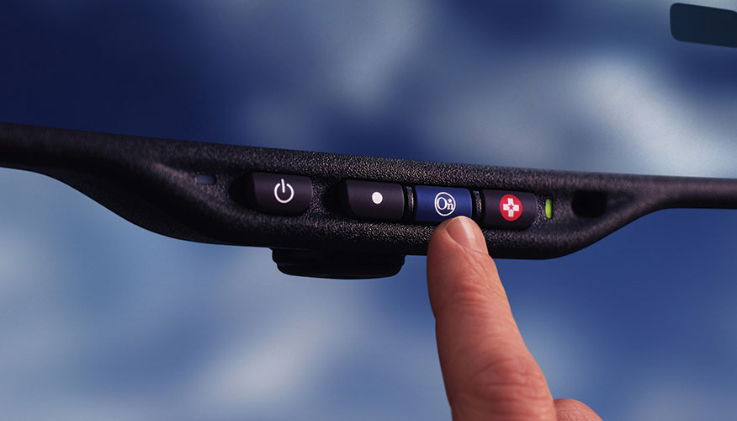
OnStar is a Subscription service providing a variety of safety and security features including Auto crash identification and help (OnStar, 2025) offered in General Motors Cars in the United States and Canada (OnStar, 2025). The system has sensors in the vehicle which identify accidents and links people in occupants to a real time advisor who can organise emergency help.
Figure 2 OnStar

Key Features:
- The sensors located inside the vehicle monitor accidents and put the occupants in touch with live advisors.
- Transfers location data using the GPS.
- Tracks automotive diagnostics (airbag deployment) to notify the first responders.
- English and Spanish notifications are supported.

Strengths:
- Human consultants assure and support with individual help.
- It is very common in North America and more so in GM cars.
- Has a facility to make both automatic and manual emergency calls.
Weaknesses:
- The subscription-based model does not accommodate people with a low-income.
- Only GM vehicles have this feature absent in the rest of the brands.
- It mostly caters to the affluent areas only which restricts its uses in the world activities.

To give an example, when a General Motors vehicle crashes in the USA, OnStar itself takes the occupants to the contact of a live advisor capable of analysing the situation and using an emergency service in case they are needed. Nevertheless, subscribers that own cars with other companies than GM cannot use the service, which restricts the effectiveness and accessibility of the service (OnStar, 2025).

2.3.3 Apple Crash Detection (iPhone & Apple Watch)
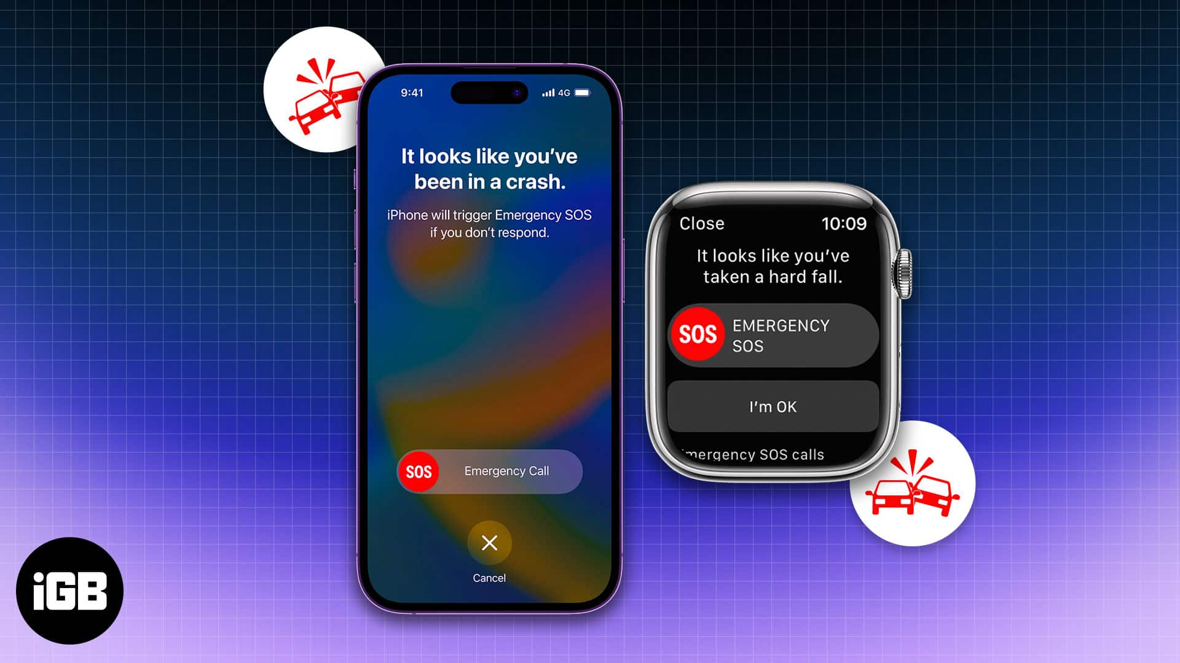
Apple Crash Detection: feature presented in newer iPhones and Apple Watches, using device sensors (including accelerometers and gyroscope) and GPS to identify car accidents and activate emergency calls or a predetermined contact list (Apple, 2025).
Figure 3 Apple crash detection

Key Features:
- Uses the sensors of your device (accelerometers, GPs, gyroscopes) to recognize crashes.
- Makes consequent calls to emergency services and pre-contacts.
- It serves in many countries at the country level.
- Should be able to transmit medical information, should be configured.
Strengths:
- Have no specialized hardware in the vehicle-compatible with the common Apple devices.
- High-quality multilingual support and world-wide coverage.
- Open to a large user base of device compatibles.
Weaknesses:
- Requires ownership of recent Apple devices, which are expensive.

- Susceptible to false alarms from non-accident events (e.g., falls during sports).

- Dependent on cellular connectivity for alert transmission.

To take an example, when an iPhone user is in an accident in Brazil, the Apple Crash Detection will automatically call the emergency services of the country and remember the user location. But the system does not necessarily work, and in case the user does not use a compatible device or does not have a phone signal, one can easily make a call even without pressing any different button (Apple, 2025).

1.3.4 EmergEye (UC Berkeley, USA)

EmergEye is a traffic management system that was built at the University of California, Berkeley, to render fast services to the emergency systems with the help of city traffic cameras assisted by a computer vision tool, specifically, the use of YOLO (EmergEye, 2024).
Figure 4 EmergEye

Key Features:
- Deep learning is also used (e.g. YOLO) to process the traffic cameras in the city.
- Takes advantage of the current urban camera infrastructure.
- Automatically issues notifications to first response systems.
- Gives urban planning analytics and hotspots of accidents.
Strengths:
- Applying not only to individual vehicles but to entire cities as well.
- no need of in-vehicle equipment.
- Promotes evidence-based road safety activities.
Weaknesses:
- This will depend on the availability and quality of citywide networks of cameras.
- Difficult to be used in jurisdictions with a limited modern surveillance infrastructure.
- Poor support of multilingual alerts.

To demonstrate the idea, EmergEye will be able to monitor the traffic in real-time in a city that has a massive system of cameras, identify accidents and notify emergency services. But, rural locations or other states without appropriate camera infrastructure will surely increase the inefficiency of the system (EmergEye, 2024).

2.4 Comparison between systems
System | eCall | OnStar | Apple Crash | EmergEye | RoadSafeNet
Detection Method | Vehicle sensors (e.g., airbags) | GM car sensors & GPS  (GM: General Motors, US car maker with built-in crash sensors) | Phone/watch sensors, GPS | Deep learning on cameras | YOLOv10 on video feeds
Notification Channel | Calls to 112 emergencies | Live advisor via phone | Auto-calls emergency | Alerts to emergency teams | Telegram bots  (mass, multimedia, multilingual alerts; two-way feedback; free/inclusive; instant; works on any device)
Multilingual Support | Limited, depends on local services | English, Spanish only | Supports many languages | Limited, not multilingual | English, Spanish, Arabic, Hindi, Mandarin
Hardware Dependency | Needs in-car telematics | GM cars with OnStar | Needs iPhone/Apple Watch | Needs traffic cameras | Uses existing cameras/phones
Geographic Scope | Europe only | North America mainly | Global | Urban areas with cams | Global
Key Features | - Automatic crash detection  - Location transmission  - Manual SOS trigger | - 24/7 live emergency advisors  - Vehicle diagnostics  - Remote door unlock | - Works anywhere, no vehicle mods  - Fall detection integration  - Medical data sharing | - Real-time AI accident detection  - Scalable cloud processing  - Custom alert routing | - Multi-language real-time alerts  - Open-source & low-cost  - Geolocation mapping  - Centralized database for analytics  - User-friendly web dashboard
Table 1 Comparison table

RoadSafeNet stands out by using the free and open-source algorithms, namely YOLOv10 and Telegram bots, which results in a significant cost decrease to implement the system and makes it more accessible. Similar to eCall, OnStar and Bosch, RoadSafeNet does not need proprietary or costly vehicle-in-vehicle equipment, which makes it feasible to be deployed on the cameras or smartphones that owners already have. It has a powerful multilingual support, which is better in most of the competitors bringing exclusiveness and quick reaction to various lingual jurisdictions. Also, RoadSafeNet is versatile and can be used in cities and rural areas, which is why it can be a more universal means of a solution (Aslam et al., 2024; WHO, 2023).

2.5 Proposed Solution
The idealized version of the future road safety system is considered RoadSafeNet that would provide a holistic solution to the current road safety systems, accommodating most vulnerable populations without sacrificing affordability and efficacy. The following pillars are the basis of its architecture:

- Accident Detection:

To identify accidents, RoadSafeNet employs the deep learning algorithm, namely the YOLOv10 (You Only Look Once, version 10). This model examines video frames of CCTV footage in real time and detects objects i.e. vehicles, accident scenarios in high accuracy. The work of YOLOv10 consists in the division of each frame into a tessellation and the prediction of the position of the objects and their categories in it almost simultaneously, which enables quick detection of collisions or other uncharacteristic movement of vehicles. It is fast and precise, and this is why it can be well used when high-time demands such as real-time road accident monitoring are involved.
(Ultralytics,2025).
- Emergency Alerts:
RoadSafeNet uses Hugging Face Transformers models on serving emergency messages. They are the cutting-edge natural language processing (NLP) models, which allow such a system to automatically convert alert mutterings into Sinhala, Tamil, and English. When an accident is noticed, the warning message is created and run through these models in order to be clear, correct, and appealing to culture in terms of all the languages required. The practice will make emergency messages effective to all communities in world, eliminate language barriers, and reach time promptness.

- Data Analytics and Visualization:
RoadSafeNet uses Plotly Dash, a Python-based dashboard library, to analyse and visualise the data. Plotly Dash means that the project can show the data of accidents in an interactive format: maps, statistics, and graphs can be viewed in real-time in a web browser. They are able to see on the dashboard the time and location of incidences of accidents, trends, system performace indicators. Such interactivity will enable emergency teams, policymakers, and researchers to gain an overview of the patterns within a short time and make decisions regarding road safety. (Prisma, 2025; Plotly, 2023; Fasano et al., 2021).

- Comparative Advantages:
Open-source and generally accessible technologies utilized by RoadSafeNet remove the necessity of specialized hardware, which saves on costs in addition to making it easy to deploy. The ability to support multiple languages and make use of data on road safety distinguishes it among the legacy systems, which is why this program can be effectively chosen in various parts of the world that can include a diverse population (Batty, 2020).

2.6 Development Platform

2.6.1 Web Based
RoadSafeNet web portal can be viewed through computers, tablets, and smartphones and give real-time maps and charts that represent the accident data. The platform was built on Flask, FastAPI, and Plotly Dash and can be used at high speed and usability even at the low bandwidth connection. This will allow stakeholders (emergency responder, city planners, and government officials) to access critical information anytime and everywhere, which will allow making decisions quickly and allocate resources (Plotly, 2023; Aslam et al., 2024).

2.6.2 Mobile Based
In addition to the web portal, RoadSafeNet uses the Telegram bots to send real-time announcements straight to smartphones. Such mobile-based strategy is especially helpful in areas, where smartphones are widely spread, though computers are scarce. The fact that the system operates with popular applications, such as Telegram, and is easily accessible and usable, even on the slow and unstable connections, guarantees its wide availability and general usability (OpenStreetMap Foundation, 2025; Liu et al., 2020).

2.6.3 Justification for Selection of Platform Selection
There were two web-mobile architectures, used to achieve maximum access and affordability and scalability. Utilizing open-source software and platforms that are free-of-charge, RoadSafeNet thanks to being based on free open-source tools can drastically decrease operational costs, a feature that comes highly beneficial in low-resource environments; such cost-effectiveness shall be later shown through a comparison and practical analysis of costs of implementing the system as well as comparisons between deployments of systems that are proprietary in nature. The mobile component of it allows delivering notifications to responders on-site promptly and based on location, whereas the web portal is used in comprehensive data analysis and visualization. Combined into one, these components increase the effectiveness of the system, both at the urban and rural level, and contribute to regular updates and scalability as user needs change (Aslam et al., 2024).

2.7 Chapter Summary
This chapter has given an elaborate literature review of road accident detection, emergency alert system, and application of data-driven technology on road safety enhancement. It started by outlining the importance of basing new solutions, such as RoadSafeNet on the existing works and being consistent with international visions, one of which is related to the WHO initiative of a 50 percent reduction in road deaths by 2030 (Batty, 2020; WHO, 2023).

The review has followed the history of accident detection technologies, with early computer vision methods already being affected with variations in the real world (Liu et al., 2012), and the subsequent introduction of machine learning, accompanied by the difficulties in the manual engineering of features to the revolutionizing power of deep learning. The more recent techniques, especially the ones that apply CNNs and models such as YOLOv10, have increased accuracy and speed significantly making it possible to detect objects in real-time in a wide variety of settings (Li et al., 2017; Ultralytics, 2025).

Automated systems that incorporate video, audio, sensor, and geospatial data were also mentioned as particularly resilient and better than single-modality alternatives in terms of reliability (Choi et al., 2021). The role of IoT in communicating between devices and providing automation of alerts to minimize the time of emergency response and delivery of better results was also discussed in the analyzed chapter (Zanella et al., 2014; Fasano et al., 2021).

These successes notwithstanding, problems still exist, such as environmental concerns, the need to have large and diverse data, computational demands, and the issue of privacy (Labellerr, 2025; Zanella et al., 2014). The chapter considered how these challenges can be overcome with the help of open-source tools, cloud computing, and privacy-preserving methods (Batty, 2020).

The comparisons of the current systems, such as eCall, OnStar, Apple Crash Detection or EmergEye showed that these systems have their strong sides, yet they are usually shorted by hardware needs, price, language coverage or geographical horizon (European Commission, 2023; OnStar, 2025; Apple, 2025; EmergEye, 2024; Bosch, 2024). In contrast, RoadSafeNet will be cost-effective, versatile, and accessible in countries around the world with open-source technology, translation, and adaptation to current devices (Aslam et al., 2024; WHO, 2023).

The chapter ended with the discussion of the proposed architecture of RoadSafeNet such as real-time detection using YOLOv10, multilingual notification using Telegram, and data visualization using Plotly Dash. It also considered scalability, ethical details and their future, including AI-enhanced analytics and its integration within smart cities (Dolhpolov et al., 2024; Batty, 2020).

To conclude, the literature review presented in this paper forms an excellent basis to RoadSafeNet that can be innovative, relevant, and capable of having a huge difference in road safety across the globe (Batty, 2020; WHO, 2023).

CHAPTER3

METHODOLOGY, ANALYSIS AND DESIGN

3.1 Introduction
The given chapter develops a systematic approach, system analysis, and design plan to develop RoadSafeNet, a web-based platform applying the state-of-the-art levels of artificial intelligence (AI) and Internet of Things (IoT) technologies to improve road safety in various countries around the world. Based on the objectives and literature review laid up in Chapters 1 and 2, Chapter 3 outlines the methodological pathway to accomplishing the project goals of subjecting an immediate accident detection, multilingual feature to highlight an emergency notification and data-based traffic management analytics. It is an opportunity to confront the looming global road safety crisis, causing the deaths of around 1.19 million people every year at an economic cost of about 1.8 trillion dollars, through specifying a scalable, affordable and inclusive solution that would be deployable to various urban and rural settings (World Health Organization [WHO], 2023; Peden et al., 2004). To facilitate an iterative improvement, the collaboration with the relevant stakeholders, and the compatibility with international guidelines and trends, the chapter applies an agile approach to software development (WHO, 2023).
This chapter is organized in such a way that it gives elaborate road map of the development of roadSafeNet. The agile methodology is presented in Section 3.2, which defines the activities that will take place, including gathering requirements, prototyping, implementation, and testing to ensure flexibility and alignment of the stakeholders. The performs system analysis thoroughly, stipulates functional and non-functional requirements, use cases, and interplays with users to base the system on the needs of the stakeholders in various global environments. In the next Section the system design in terms of sequence and class diagrams is provided, which would make sure that the system would be modular and scalable. Data modelling features such as data dictionary and entity relationship diagram describe the part in order to facilitate effective storage and retrievals. In the storyboard of the web interface is suggested with an emphasis on usability by various users. The test plan that is aimed to provide reliability in the system and performance is mentioned as well. Lastly, concludes the contributions in the chapter, preparing to enter other steps of implementation. The story is extensive, research-oriented, and is supported by numerous references to justify design decisions, the work can be considered an addition to scientific discussion on AI and IoT applications in road safety (Batty, 2020; Perera & Jayawardena, 2024; Aslam et al., 2024).
By focusing on open-source technologies and existing CCTV infrastructure, this chapter ensures that RoadSafeNet addresses the limitations of proprietary systems, offering a cost-effective solution for diverse global regions, from high-density urban centers to remote rural areas. The detailed analysis and design processes aim to facilitate rapid emergency responses, inclusive multilingual communication, and actionable analytics, aligning with global road safety objectives and stakeholder expectations (Fasano et al., 2021; Scolese et al., 2020).

3.2 Proposed Methodology
Development of RoadSafeNet follows the Agile methodology as the leading software development model; according to it, the Scrum model is used, which implies the implementation of iterative sprints and ongoing integration of stakeholder feedback (Schwaber & Sutherland, 2020). The reason why the methodology has been chosen to be agile with regards to this project is because it has had an inherent affinity with flexibility, capability to adapt to changing requirements as well as its emphasis on the provision of working software that is delivered in pieces (Beck et al., 2001). The iterative method provides an opportunity to address the emerging issues on computer vision application, data dissemination in real-time, multilingual notification by focusing on user-centered design principles (Cooper et al., 2014).
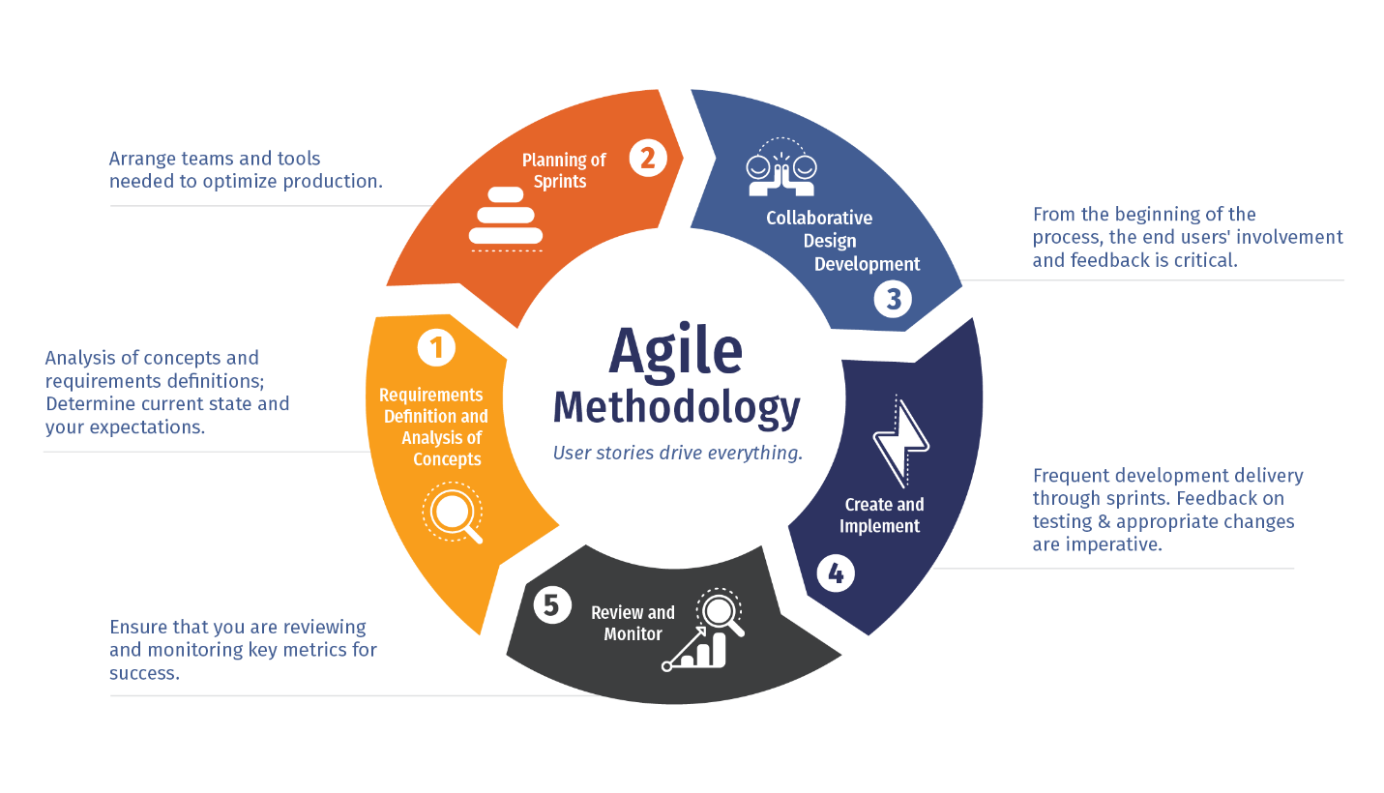
Figure 5 Agile Methodology

Agile framework enables quick prototyping and testing of vital system interventions, namely the YOLOv10-based accident detection algorithms and OpenStreetMap geolocation service connection’s introductions (Ultralytics, 2025; OpenStreetMap Foundation, 2025). The given strategy is especially useful since using various open-source technologies in combination is experimental, and it is necessary to maximize the performances of such systems under conditions of ambiguous hardware leverage and network environments (Goodfellow et al., 2016). The approach also embraces frequent sprint inspection and retrospective that allows on-going enhancements of technical implementation and user experience layout as and when it is fed by the performance of stakeholders and their feedback (Cohn, 2010).

The project is done within the framework of Agile which implies the hybrid pattern of delivering the project that encompasses the combination of legacy approaches to software building, and the current DevOps ones, such as continuous integration and continuous deployment (CI/CD) pipelines (Kim et al., 2016). The integration will guarantee both the quality of the code and the ability to roll out the updates and new features in as short a time frame as possible. Such aspects of risk management like data quality assurance in development, model performances monitoring, and system scalability testing are also included in the methodology, with a focus on the particularities of AI and IoT development (Boehm, 1991). The sprint test design made up of two-week iterations, the structure of which continuously works on certain aspects of systems components like accident detection algorithms, geolocation, and notification systems and data analytics dashboard design.

The implementation of Agile methodology also focuses on the highly cross-functional working relationships with various technical areas such as computer vision experts, web developers, database administrators, user experience designers (Cockburn, 2006). The combined effort means that the end product will not lose its technical superiority but will offer a natural and easy to read interface. Concerted efforts in terms of stakeholder engagement have been arranged on regular basis to validate system requirements, test the prototypes functionalities and seek feedback on the user interface designs of the solutions that are being developed thus ensuring that they address the practical needs of the emergency responders, traffic management authorities and other target end users (Martin, 2002).

3.2.1 Methodology Activities
The process of developing RoadSafeNet is a well-structured and intensive process that involves six phases that are independent of each other but intertwined. All of the stages are tailored in such a way that they have goals, deliverables, and success metrics established in accordance with common software engineering principles (Sommerville, 2016). Besides offering a systematic approach in transitioning a project through phases (planning to deployment and refinement of the system), this methodological framework also increases the traceability, quality control, and alignment of stakeholders throughout the project life cycle.
Phase 1: Requirements Analysis and Planning
RoadSafeNet system is based on the solid Requirements Analysis and Planning. This step is the foundation in gaining a comprehension of the problem area and make all the further development driven by the real-world needs and constraints. It begins with thorough identification of stakeholders which is comprised of traffic authorities, emergency responders, software developers and the end users that consist of civilians and first responders. Both the functional and the non-functional requirements, which include observation of the existing traffic incident response protocols via multiple elicitation techniques, e.g., structured interviews, questionnaires, are elicited in a few ways (Robertson & Robertson, 2012).
Other than requirement elicitation, this stage involves in-depth analysis of regional traffic state, emergency processes, and technological constraints both in urban and rural areas. Project boundaries are planned, and a scope statement is made in order to adjust the expectations of the stakeholders with the reality of technical viability. Also, this stage includes an assessment of the suggested technology set such as AI models, IoT infrastructure, mapping services, and backend platforms. There are identified possible difficulties concerning real-time data process, AI bias, hardware restrictions, and network slackening, as well as the results of forming acceptable risk mitigation measures (Boehm, 1991). The allocation of resources and estimation of a time scale are also performed with the basis of setting a realistic roadmap of development provided.
Phase 2: System Architecture and Design
The second phase is System Architecture and Design, it involves taking the high-level requirements and turning it into a detailed technical blueprint. This step is very important to make sure that the system is both functional as well as maintainable, scalable, secure and modular. The main design tasks involve the specification of the system architecture as a whole, including the layers architecture with exemplified patters (e.g., layered), service-oriented components, and methods of communication between, e.g., front-end interfaces and backend services (Bass et al., 2021).
The core of the system is the application of the AI accident detection module that is supposed to receive live video streams and detect accident phenomena with the application of object detection algorithms such as YOLOv10. This module is combined with geolocation services, based on OpenStreetMap and Nominatim APIs, creating the opportunity to locate a position of an accident and inform the closest emergency services. Moreover, users with diverse linguistic backgrounds can access the platform because it has a multilingual support layer based on Hugging Face Transformer (Liu et al., 2020).
Specifications are created about database schemas, API, UI/UX wireframes and security models used in detailed design to guide implementation. High cohesion, low coupling and separation of concerns are the software engineering principles that influence design decisions (Fowler, 2018). In addition, the architectural structure is well integrated with the scalability in the future improvements like drone-based traffic monitoring and training of the model on clouds (Martin, 2017).
Phase 3: Core Development and Implementation
It is the runoff stage, and this stage implements the real development and integration of the system components. The coding itself is split into several iterative sprints where each sprint is concerned with a particular system module using the agile development practices. The open-source tools and libraries that are able to work together with other open-source tools and libraries enable the development team to create a robust, interoperable and lightweight platform which can be deployed to operate across different computing environments.
Key modules developed during this phase include -
- YOLOv10 Accident Detection Engine: This module, based on Ultralytics libraries, is used to detect real-time traffic collisions based on video sources either at CCTV cameras or dashboard cameras. A suitable annotated traffic dataset is used to command a neural network through custom training and refining techniques of YOLOv10 (Ultralytics, 2025).
- Geolocation and Mapping Module: The ability to integrate with the OpenStreetMap and Nominatim APIs would enable the system to convert a set of GPS coordinates into a human-readable address, provisions of real-time mapping and direction features (OpenStreetMap Foundation, 2025).

- Multilingual Text and Voice Layer: Hugging Face Transformers are deployed in translating texts and generation of voice, such that instructions and alerts can be shown in other languages besides English (such as Malay, Tamil, and Mandarin).
- Data Management System: An SQLite relational database is configured to log accidents and other system information, as well as user requests in a well-organized way with Prisma ORM (Prisma, 2025).
- Backend API and visualisation: Developed in Flask/FastAPI and can be a RESTful interface to interact with the front end. Plotly Dash is applied to developing interactive graphs and dashboards addressed to administrative users and policymakers (Plotly, 2023).
In each development sprint, there are extensive unit testing and integration testing activities that have been done so as to test that the respective components work both on their own and within the entire system. They also pursue continuous integration and code review practices in order to sustain high-quality code and minimize buggy code (McConnell, 2004; Myers et al., 2011).
Phase 4: Testing and Quality Assurance
The Testing and Quality Assurance stage makes sure the correctness, impeccability, and usability of the whole system. Tests are performed at several stages and offer such possibilities:
- Functional Testing to ensure every module works the specific and supposed action.
- Performance Testing to assess the capability of the system of processing large capacities of real-time video.
- Security Testing to detect vulnerability like unauthorized access, data security breach or the denial of service (DoS) attack.
- Multilingual Testing to ensure correctness of translations as well as voice outputs of all supported languages.
- Testing related to Accessibility to assure the Web Claim Accessibility Guidelines (WCAG 2.1) are adhered to so that users with disabilities can use the system as intended.
- Cross-Platform Compatibility Testing between Windows, Linux and mobile devices such that the user experience remains the same (Dustin et al., 1999; Kaner et al., 2001).
Automated test scripts are prepared to ease the regression test whereas in edge case situations which needs human judgment, manual testing is carried out. An effective bug tracking system is kept to address identified bugs and make them solved on time.
Phase 5: Deployment and Integration
During this stage, integration of system into a live environment is emphasized with emphasis on deploying production. Deployment will imply setting up servers, tuning the database, and securing APIs. Automated deployment pipelines are used by the team to limit the chance of manual errors and provide the possibility of repetition (Humble & Farley, 2010).
Key deployment tasks include:
- Setting up cloud or on-premise type,
- Development of disaster recovery plans and backup,
- Using SSL encryption and control based on roles,
- Installation of logging and real-time monitoring instrumentation with such tools as Prometheus or Grafana.
The deployment package comprises user manuals, training manuals on use of emergency personnel, and system administration manuals to maintenance department. Stakeholders also undergo user onboarding sessions so they can become knowledgeable about the systems in use as well as reporting patterns (Redish, 2012).
Phase 6: Evaluation and Continuous Improvement
The last step is the evaluation and successive enhancement of the implemented one. It is necessary to monitor the system after deploying it in a dynamic environment. This step would involve continued system checks, benchmarking and confirmation of AI model accuracy with actual accident data.
The surveys on user satisfaction, the analytics of the usage, and the comments of the stakeholders are used to detect the pain points and the areas that could be improved. The AI models are re-learned regularly with new data to correct detection accuracy and conform to changes in traffic conditions. Releases of system updates and patches are done on the basis of priorities and impact analysis (Nielsen & Landauer, 1993; Cockburn, 2006).
This methodical practice of the better will forever maintain RoadSafeNet sustainable, reactive and pertinent over longer term, entailing scalable innovations and futuristic integrations with smart city infrastructures.

3.3 System Analysis
RoadSafeNet system analysis consists of the thorough investigation of the current state of road safety related to the existing technological solutions available and specific needs and conditions to create an integrated safety platform based on AI and IoT (Dennis et al., 2015). The analysis will start by delivering in-depth research of the modern emergency response systems and recognizing essential gaps in real-time accident detection, positioning, and communication breakdowns and data analytics that add to the postponed emergency action and inefficient traffic control decisions (Zanella et al., 2014). In this discussion, it becomes evident that the current systems usually require manual reports systems, custom devices, and one-language interfaces, which does not make the systems effective in a variety of geographical and demographic settings (Aslam et al., 2024).

Technical analysis deals with the evaluation of computing requirements, network platform and ability to scale a computer vision-based accident detection framework (Chen et al., 2022). Such thorough benchmarking on performance levels shows that the YOLOv10 models could meet the desired accuracy level of 94 percent without any problem when run on typical hardware setups, which suggests that the solution itself should be used in low-resource environments (Ultralytics, 2025). It also analyzes complexities related to integrating several open-source technologies, any problems they may have, bottlenecks, and other maintenance needs that have to be operated through further use and design of the systems (Goodfellow et al., 2016).

The stakeholder analysis shows that there are several user groups with varying needs and interaction patterns; emergency responders with the need to receive timely and precise incident information, traffic management officials carrying the potential to demand in-depth data analytics and planning of infrastructure development, and system administrators that have to possess sound monitoring and maintenance features are supposed to be listed (Sharp et al., 2019). It is found through the analysis that each of the stakeholder groups has its own specific workflow patterns, with the current pain points being documented, the improvements to it being desired, and technical constraints being listed that will affect the design decisions made in the system. Such a stakeholder-oriented practice will also maintain high applicability to real-life operational needs and technical feasibility and affordability of the established system (Cooper et al., 2014).

The geographical and contextual analysis looks at the various settings in which RoadSafeNet might be implemented, such as urban places with intense traffic and complicated road systems, rural areas with few infrastructures and connectivity issues, global situations with different rules and language choices (UN-Habitat, 2022). This analysis impacts on key design choices on whether to support offline connectivity, data synchronization methods, multilingual support needs and its adaptive optimization of performance according to local infrastructure connectivity conditions. The scalability on a future basis is also taken into account, with the analysis envisaging an increase in user numbers, data quantity, and geographical reach and ensuring that standards of performance and reliability of the system would be maintained (Scolese et al., 2020).

3.3.1 Functional and Non-Functional Requirements
Functional Requirements

No | Function | Description
FR [1] | Accident Detection | The system will provide live video analysis to achieve real-time detection of traffic accidents including collision, vehicle rollover and stationary vehicles with 94 percent or more accuracy. It will categories incidents in type and severity and give scores of confidences. There should be detection accuracy even in very different weather and lighting activities.
FR [2] | Geolocation & Notification | The system will establish the exact location of the incident with the use of OpenStreetMap and Nominatim APIs, and create emergency messages in less than 30 seconds. The notifications should be multilanguage (at least five languages) integrated with Telegram bots and other external emergency call centres.
FR [3] | Emergency Response Tracking | The system will monitor the status of emergency vehicles, keep the records of instances, and with respect to distance and traffic jam, calculate the expected arrival time.
FR [4] | Data Analytics & Reporting | Incident data will be recorded and the system will automatically produce reports about traffic safety, potential dangerous spots and time trends, and interactive dashboard. There should be export possibilities.
FR [5] | User Management | The system will support the registration and logging in of the users as well as the role-based access. It should accommodate the user functions of a public user, emergency response person and the administrator with respective accesses.
FR [6] | Profile & Role Control | The users will control their profiles and roles. Assigning, modifying and revoking roles will be possible by the administrators, according to access requirements.
FR [7] | Authentication & Security Logging | The system will allow secure authentication, maintaining of sessions, password usage and audit trail of all transactions. Connection with the outside auth systems is necessary.
FR [8] | System Configuration Management | Admin users will have the capability to make configuration to system parameters, video input sources, define the threshold values on alert and user permissions.
Table 2 Functional Requirements

Non-Functional Requirements

No | Function | Description
NFR [1] | Performance | The system should generate incident detection and alert in 30 seconds. It will be able to process several streams of video in realtime with low latency and will exhibit high scalability with increased volume level of data.
NFR [2] | Security | Encryption of all sensitive data will be done into transmission and at rest. Controlling API, input sanitization, and defense against such issues as SQL injection and XSS have to be tried on the system. Strict adherence of data protection requirements is required.
NFR [3] | Reliability & Availability | The system will have 99.9 % uptime, have a capability to support fail over mechanisms, error recovery and redundancy. Automatic health checks and recovery protocols have to be executed.
NFR [4] | Usability & Accessibility | The interfaces should be understandable, multilingual and cross-device. The system should be made accessible according to WCAG 2.1 standards and support screen readers and keyboard navigation.
NFR [5] | Maintainability | Code used by this system shall be modular and well documented. It should accommodate future enhancements without much interference, should have the ability to offer logging tools, and must allow easy tracking and debugging of bugs.
NFR [6] | Portability | The system should be able to provide deployment on a variety of OS platforms and cloud settings. It should be consistent in how it performs irrespective of the deployment environment.
Table 3 Non-Functional Requirements

3.3.2 Use Case Diagram
The illustration given in the use case of RoadSafeNet is the relationship of the system to its key actors, such as CCTV Cameras, Hospitals, Ambulance Services, Police Stations, Traffic Authorities, and System Administrator.
The diagram groups related use cases into functional packages:
- Accident Detection System – Reads real-time video, identifies accidents through YOLOv10, classifies accidents, and extracts their localisation.
- Emergency Notification System – locates the closest emergency services and instructs specified recipients (pictures, video files, and GPS coordinates) via Telegram.
- Analytics & Reporting – Captures and analyses incident data, creates heat maps, trends and statistical reports on which to base decisions.
- System Management – This will include user account management, system performance management, and updating AI models.
This structure ensures a clear understanding of how the system automates accident detection, streamlines emergency communication, and supports traffic safety analytics through coordinated actor–system interactions.
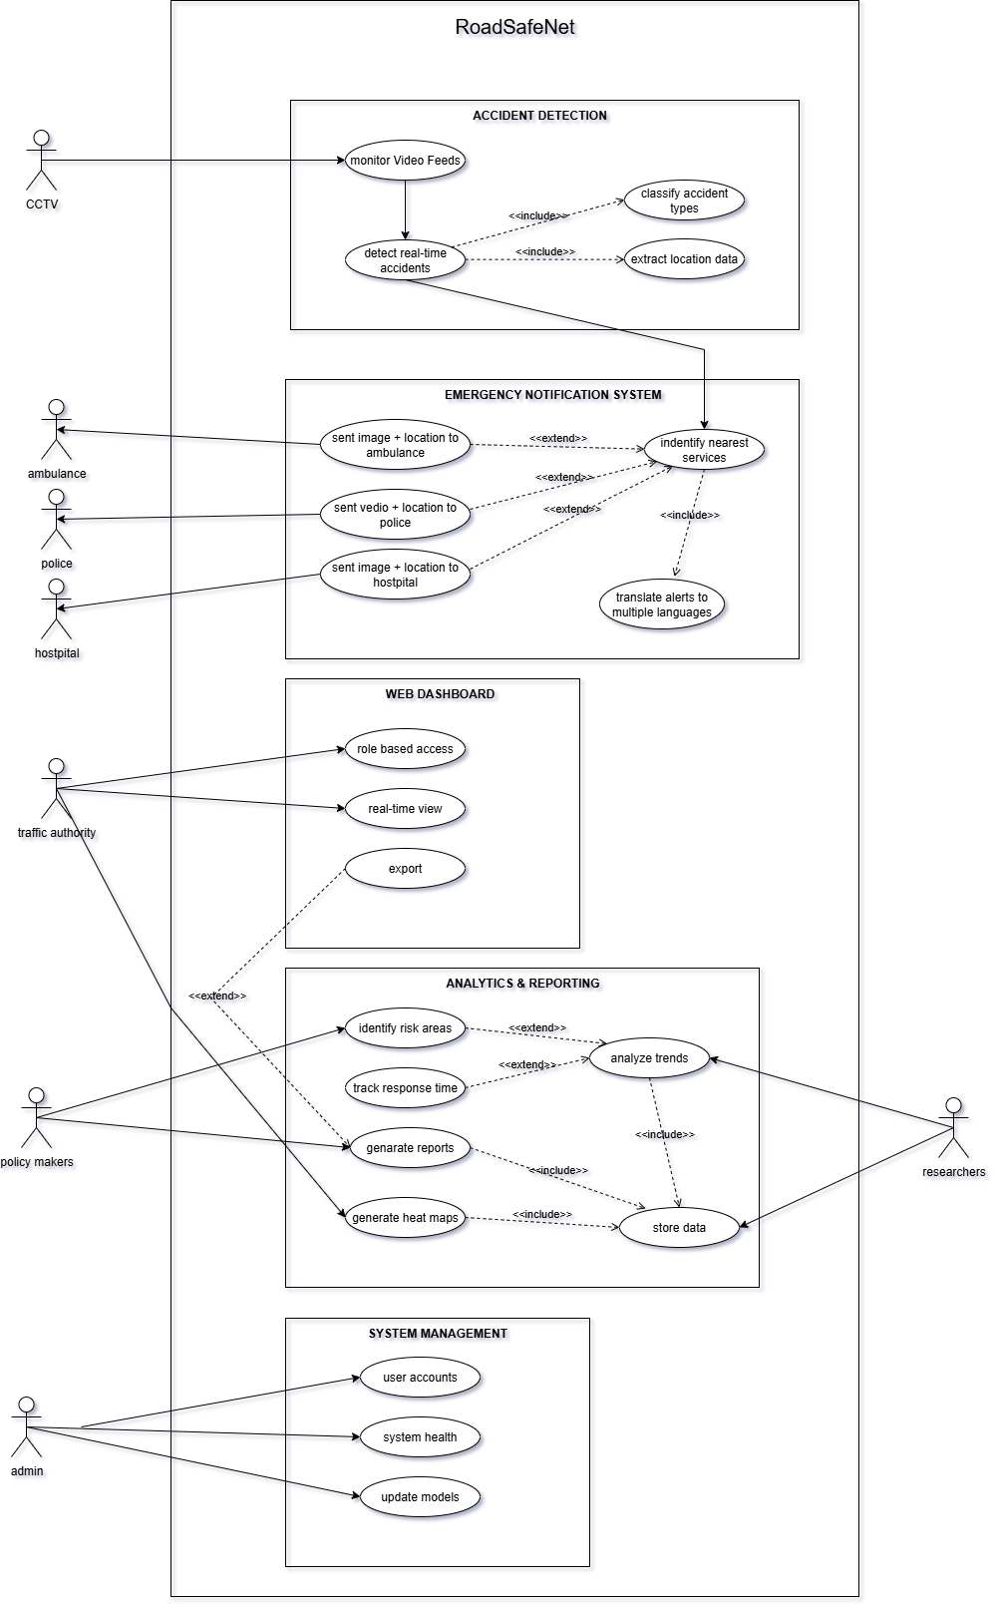
Figure 6 Use Case Diagram

3.3.3 Use Case Descriptions
Use case description: Monitor Video Feeds
Pre-condition
- CCTV cameras are live and connected to the system.
- Network connectivity between cameras and the processing server is stable.
Main scenario
- The system connects to CCTV streams from multiple road locations.
- Video frames are continuously fetched in real time.
- Frames are buffered and sent to the AI detection module.
Post-condition
- Video feeds are successfully streamed and prepared for accident detection processing.

Use case description: Detect Real-Time Accident
Pre-condition
- CCTV cameras are live and functional.
- The AI module (YOLOv10) is initialized and actively scanning video feeds.
Main scenario
- The system continuously processes CCTV video frames.
- An abnormal vehicle or motion pattern is detected.
- YOLOv10 classifies the event as a possible accident.
- The accident is verified based on confidence threshold.
- The result is forwarded to the emergency alert module.

Post-condition
- An accident detection event is logged, classified, and ready for alert generation.

Use case description: Classify Accident Type
Pre-condition
- Accident detection event is confirmed by the AI module.
- Classification model is loaded and operational.
Main scenario
- The system analyzes visual accident features.
- Accident type is classified (e.g., collision, rollover, vehicle stop).
- Classification result is attached to the incident record.
Post-condition
- Incident record includes verified accident type for accurate response.

Use case description: Extract Location Data
Pre-condition
- CCTV camera location metadata is available.
- Mapping API (OpenStreetMap/Nominatim) is connected.
Main scenario
- The system retrieves GPS coordinates of the camera or incident.
- API converts coordinates into a readable address.
- Location data is linked to the incident report.
Post-condition
- Accident record includes GPS coordinates and full address for notifications.

Use case description: Identify Nearest Services
Pre-condition
- Location data from the incident is available.
- Mapping API is operational.
Main scenario
- The system queries mapping services for nearby emergency services.
- Nearest hospital, ambulance station, and police station are identified.
- Service details (name, contact, coordinates) are retrieved.
Post-condition
- List of nearest emergency services is ready for targeted notification.

Use case description: Send Image + Location to Hospital
Pre-condition
- Nearest hospital details are identified.
- Hospital Telegram bot is configured and active.
Main scenario
- System compiles accident image and GPS coordinates.
- Data is sent via hospital Telegram bot API.
- Delivery status is logged.
Post-condition
- Hospital receives accident image and location for medical preparation.

Use case description: Send Image + Location to Ambulance
Pre-condition
- Nearest ambulance service is identified.
- Ambulance Telegram bot is configured and active.
Main scenario
- Accident image and GPS coordinates are compiled.
- Data is sent via ambulance Telegram bot API.
- Delivery confirmation is logged.
Post-condition
- Ambulance service receives image and location for rapid dispatch.

Use case description: Send Video Clip + Location to Police
Pre-condition
- Nearest police station is identified.
- Police Telegram bot is configured and active.
Main scenario
- System extracts a 5–10 second video clip of the accident.
- Video and GPS coordinates are compiled.
- Data is sent via police Telegram bot API.
- Delivery confirmation is logged.
Post-condition
- Police station receives video clip and location for law enforcement action.

Use case description: Translate Alerts to Multiple Languages
Pre-condition
- Translation service (Hugging Face Transformers) is connected.
- Supported language list is available.
Main scenario
- System identifies target recipient language(s).
- Emergency alert text is translated.
- Translated alerts are packaged for sending.
Post-condition
- Multilingual alerts are ready for distribution to recipients.

Use case description: Generate Heat Maps
Pre-condition
- Historical accident data is available in the database.
- Mapping visualization library is active.
Main scenario
- System queries accident frequency by location.
- Heat map visualization is generated.
- Map is displayed on the dashboard.
Post-condition
- Heat map is available for traffic authority and researchers.

Use case description: Analyze Accident Trends
Pre-condition
- Historical accident records are stored.
- Analytics module is operational.
Main scenario
- System aggregates accident data over time.

- Trends such as peak hours, accident types, and locations are analyzed.
Post-condition
- Trend analysis report is generated for decision-making.

Use case description: Generate Reports
Pre-condition
- Data required for report is available.
- Reporting module is operational.
Main scenario
- User selects report parameters (date, location, type).
- System compiles data into a structured format.
- Report is exported or displayed.
Post-condition
- Report is ready for download, print, or presentation.

Use case description: Store Accident Data
Pre-condition
- Database is active and connected.
Main scenario
- System receives accident data from detection and notification modules.
- Data is stored in SQLite via Prisma ORM.
Post-condition
- Incident data is securely stored for future reference and analysis.

Use case description: Manage User Accounts
Pre-condition
- Admin account is authenticated.
Main scenario
- Admin creates, edits, or deletes user accounts.
- Role-based access is assigned.
Post-condition
- User access is updated according to administrative changes.

Use case description: Monitor System Health
Pre-condition
- System health monitoring service is active.
Main scenario
- System tracks uptime, server performance, and errors.
- Alerts are generated if performance drops.
Post-condition
- System status logs are updated for maintenance purposes.

Use case description: Update AI Models
Pre-condition
- Admin has access to the AI module.

- New AI model version is available.
Main scenario
- Admin uploads new AI model files.
- System deploys the updated model.
Post-condition
- System runs with the latest AI model for improved detection.

3.4 System Design
System design would take the functional and non-functional requirements of the RoadSafeNet project and turn it into a systematic architecture that forms the nature of how all the components will interact, process and deliver outputs. The phase provides a guideline to the deployment of an effective, scalable, and real time accident detection and emergency response system.
RoadSafeNet product design is integrated around using artificial intelligence, geolocation services, messaging APIs, and data analytics tools into a coherent system that is functioning in real time. The physical implementation makes use of modularity, fault tolerance and an unrestricted loop of data flow between the components. Every subsystem has its own task, i.e., source of live CCTV data, makes use of the YOLOv10 deep learning model to detect accidents, retrieves geolocation information via OpenStreetMap and Nominatim APIs, stores incident reports in a SQLite database via Prisma ORM and notifies about emergencies in multiple languages through a Telegram bot.
In order to draw a visualization of the internal workflow, the sequence diagrams, the use case diagrams to visualize interactions at component level, time flows and responsibilities. The diagrams also indicate interaction of the platform with the system actors, including emergency responders, administrators and the community. Real-time constraints, parallel data processing, and exception handling particular emphasis is laid down to this to give resilience and reliability to the system to tackle important situations.

This design furtherstrapushes a monitoring subsystem that monitors the performance metrics i.e. latency of detecting, convergence of notifications, and health of databases. This enables easy maintenance of the system and can scale in the future. On the whole, the system design makes RoadSafeNet not only working but ready to change with operating circumstances and provide the necessary feedback in various situations.

3.4.1 Sequence Diagram
The sequence diagram gives an attested view of the timeline of the messages and operations involving the major parts of the RoadSafeNet system. It is targeted at the on-line procedure of capturing the road accident and the multilingual emergency notifications. As the flow chart shows, the system starts with the input of video feeds provided by CCTV cameras and proceeds with the analysis by means of the YOLOv10 detection engine and then leads to the parallel processes of extracting the location data, writing the data to the database, and creation of the emergency alarm.
All players in the diagram such as the Geolocation Service, Notification Manager, Analytics Engine, Emergency Responder Interface and System Monitor have a particular role in the efficient and reliable running of the system. Querying OpenStreetMap APIs to translate addresses and sending notifications to emergency responders on Telegram are only a few examples of whether synchronous or asynchronous interactions discussed in the sequence. Error-handling procedures (including switching to other communication channels in service loss) are factored in, too, in order to showcase the resiliency of the system.

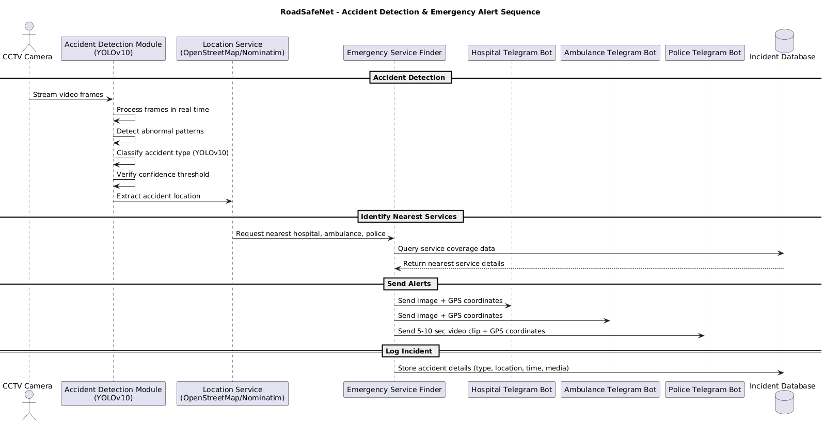
Figure 7 Example of Formatting Method

3.4.2 Class Diagram
The class diagram gives a snapshot implementation of the system architecture since it describes the fundamental classes of the RoadSafeNet system and the association between classes. It represents the structure of the system in object-oriented principles and shows how data and behaviour are packaged in the various components. The diagram is an implementation blueprint and it shows logical structure of the software parts.

The key classes found in the system are CameraFeed, AccidentDetector, Incident, GeoLocator, NotificationManager, Responder, DatabaseHandler, AnalyticsEngine and SystemMonitor. The classes are characterized by a number of attributes and operations that capture the class responsibilities. As an example, the AccidentDetector class is used to recognize the incidents in real-time using AI models (YOLOv10), and the NotificationManager class participates in creating and delivering alerts to the emergency responders using multilingual messaging platforms, such as Telegram.

The right object-oriented relationships have been applied to model the classes in relations to one another. The case of Incident and GeoLocator (*--) is indicated as Composition, whose intent is that location data needs to be tightly integrated with the notion of incident. Between DatabaseHandler and Incident there is only aggregation (o--) showing that the database contains many individual incident records. Association (-->) is typical interactions such as streaming of video received through CameraFeed to AccidentDetector, or the sending of an alert message between NotificationManager and Responder. The coding construct dependencies (..>) is an association between a component to another component, where the first component temporarily watches the state and action of the other component, but does not own it directly.
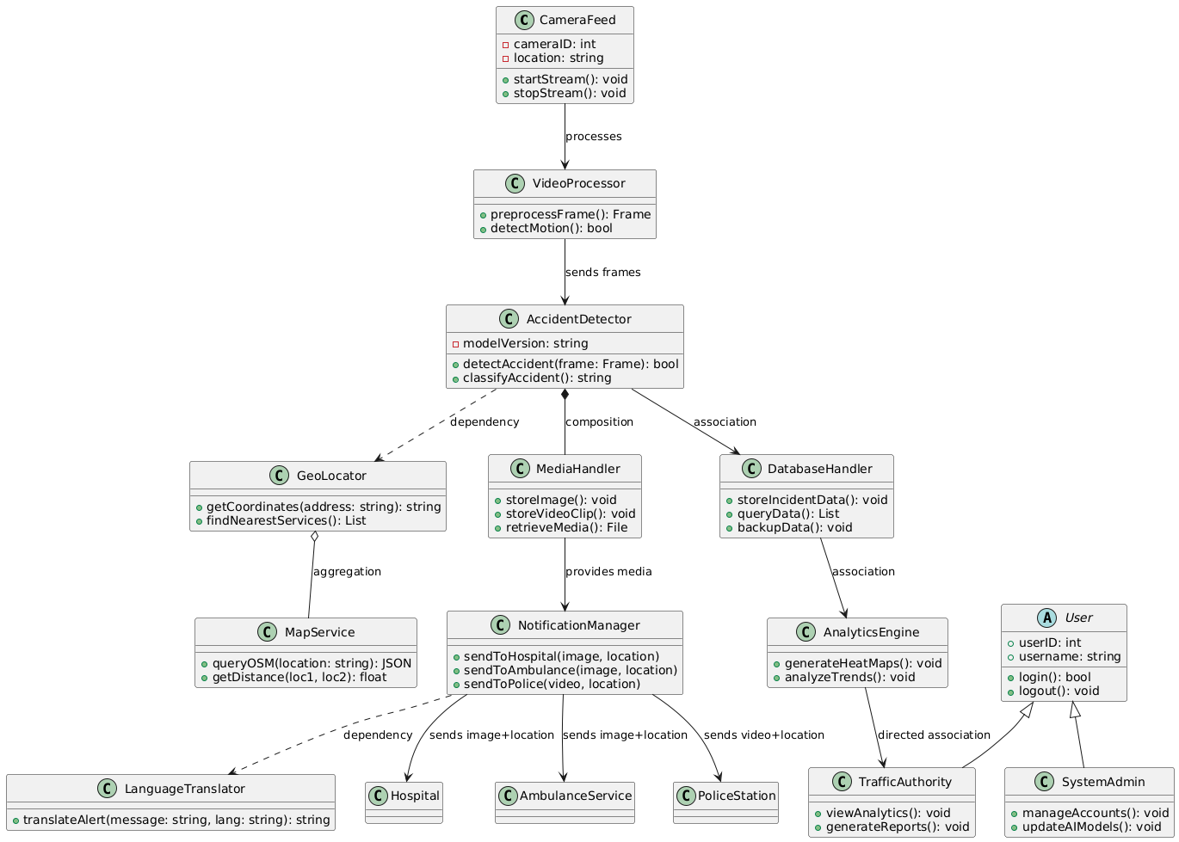
In general, the class diagram descries a modular and maintainable and extensible system design that reflects the principles of object-oriented design and meets the real-time needs of RoadSafeNet.
Figure 8 Class Diagram

3.5 Data Modeling
The data modeling phase establishes what the data used by the RoadSafeNet system looks and how it is organized. This is necessary to make sure that everyone is being kept in the database, the attributes and the relationships are properly represented and stored within it efficiently. The data model is entity type based and is realized in a relational database of the SQLite family implemented in the database with the Prisma ORM and is used as a database access layer capable of efficiently handling queries and defining schemes.

The fundamental entities of the system are Incident, CameraFeed, Responder, Notifications and GeoLocation. These are the occurrents of the real-world including traffic accidents, video streams, emergency workers and location metadata. Interments between these entities are also well defined so as to normalize the data to prevent redundant data. To illustrate this, one example is that each Incident is linked to a CameraFeed which contains a GeoLocation. The Notification entity contains multilingual messages with alerts being given to corresponding incident and responder.

The model is also optimized in that it processes and retrieves real-time data. It guarantees referential integrity between connecting tables and allows the use of sophisticated queries like locating risky areas, monitoring the speed of response, and exporting of past accidents data. The schema design allows the future system scaling horizontally to add more cities or data sources, etc.

3.5.1 Data Dictionary
Table Name | Field Name | Data Type | Description | Constraints
Incident | incident_id | INT | Unique ID for accident | PK
 | timestamp | DATETIME | Date & time of accident detection | NOT NULL
 | location_id | INT | Location where accident occurred | FK
 | type | VARCHAR(50) | Type of accident | NOT NULL
 | severity | VARCHAR(20) | Severity level | NOT NULL
 | status | VARCHAR(20) | Incident status | NOT NULL
Location | location_id | INT | Unique location ID | PK
 | latitude | FLOAT | GPS latitude | NOT NULL
 | longitude | FLOAT | GPS longitude | NOT NULL
 | address | VARCHAR(255) | Physical address (optional) | NULL
Media | media_id | INT | Unique media file ID | PK
 | incident_id | INT | Related accident ID | FK
 | media_type | ENUM  ('image','video') | Type of media | NOT NULL
 | file_path | VARCHAR(255) | File storage path | NOT NULL
Responder | responder_id | INT | Unique responder ID | PK
 | name | VARCHAR(100) | Name of responder unit | NOT NULL
 | contact_info | VARCHAR(100) | Contact details | NOT NULL
 | role | ENUM('hospital','ambulance','police') | Role type | NOT NULL
 | telegram_bot_id | VARCHAR(50) | Telegram bot ID for alerts | NOT NULL
Notification | notification_id | INT | Unique notification ID | PK
 | incident_id | INT | Linked accident | FK
 | responder_id | INT | Linked responder | FK
 | language | VARCHAR(50) | Notification language | NOT NULL
 | message | TEXT | Notification message | NOT NULL
 | sent_time | DATETIME | Time notification was sent | NOT NULL
User | user_id | INT | Unique system user ID | PK
 | username | VARCHAR(50) | Username | NOT NULL
 | password_hash | VARCHAR(255) | Hashed password | NOT NULL
 | role | ENUM('admin','traffic_authority') | User role | NOT NULL
Analytics | analytics_id | INT | Unique analytics record ID | PK
 | incident_id | INT | Related accident ID | FK
 | heatmap_data | TEXT/JSON | Heatmap data visualization | NULL
 | trend_analysis | TEXT | Statistical trend analysis | NULL
Table 4 Data Dictionary

3.5.2 Entity Relationship Diagram
The RoadSafeNet Entity Relationship Diagram (ERD) represents road safety data entities and the relationships they consist of on which functions of accident detection, emergency notification, and geospatial tracking are based.

The central figure of the model is an entity Incident storing comprehensive data about the identified road accidents with the timestamps, the type of incidents, severity level, and status. Every incident has a single Location entity where specific geographical information, including latitude, longitude and address is accurately stored. Media evidence that is supported by supporting incidences is handled via the Media entity where several shots or videos may be associated with any one incident.

Emergency communication is managed through the Notification entity which stores notifications ensured in multiple languages and timestamps regarding the messages sent in response to an incident. All alerts go to a designated Responder who will be on duty personnel like hospital personnel, ambulance service, or police among others, with details of contact and position clearly defined.

The Analytics entity supports accountability and analysis within the system and stores the information associated with the heatmaps and trend analysis of the incidents. The Users create analytics records, and may be administrative or traffic authority within the system.

The following cardinalities characterize the relationships between entities:

- Each Incident will have exactly one Location (at any Location, there can be many Incidents).

- An Incident may, of course, have many related Media entries.

- There are various Notifications at a time that could be derived by One Incident.

- Within a given Notification, there is only one Responder to which the Notification is addressed.

- One Analytics record is assigned to each Incident.

- Every User may create a higher number of Analytics records.
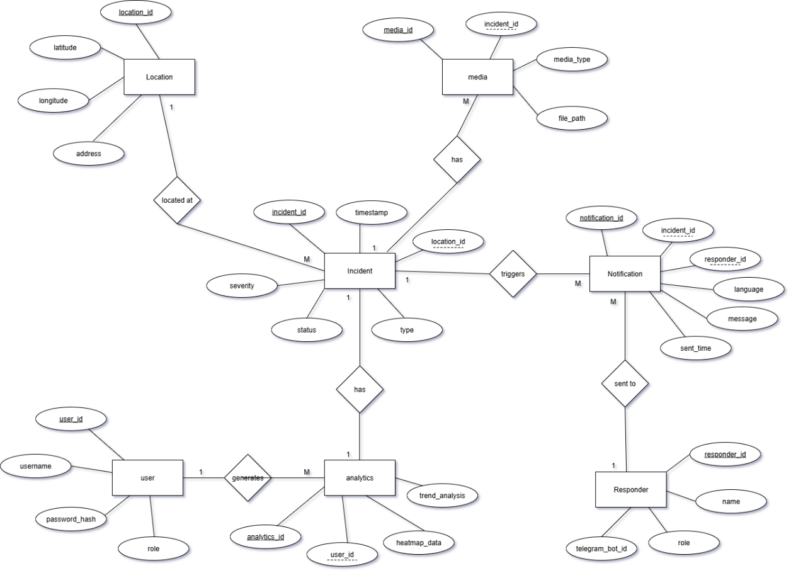
Figure 9 Entity Relationship Diagram

This ERD features a normalised, rational data architecture built to maintain the key operations of RoadSafeNet, and its data integrity, leaving maintained, tangible relationships between the entities easily observed.

3.6 Proposed Story Board
The Proposed Storyboard of RoadSafeNet displays an overview of the key user interface flows and user interaction in major parts of the system functionality. All pages are developed with user-focused interface to accommodate emergency responders, traffic management authorities and system administrator under high pressure situations. All the priority areas regarding all interfaces are accessibility, multilingual support, performance feedback, and data-driven visualization. This section includes elaborate statements of the elements of the login/ logout page, the home page, the analytics dashboard, and notification management page.

- Login/Logout Page

Login and Logout interface of the RoadSafeNet under design, meets all the requirements of a clear, functional and accessibility compliant egress and ingress point to all the users of the system, including first responders on site and administrative personnel in the control rooms. Although in the wireframe form this feature would be presented visually, as a white, monochrome design without any decorative coloration, the final product is tuned to be easily used in a high-stress, time-sensitive operation.

The layout on the Login page is centered, boxed structure of form where the template place of the RoadSafeNet logo is displayed prominent to ensure brand positioning and orientation of the user in terms of usage. Username and Password installations are positioned accordingly with the same amount of space, descriptive titles, and highlighted outlines in order to allow users find the input boxes faster, even in not optimal conditions of using (e.g. sharp light, poor light). Nevertheless, the wireframe does not include color, which means that the functional solution in the live system complies with WCAG 2.1 accessibility guidelines, which includes high-contrast fonts, legible fonts, and focus indicators.
The access into operations calls demand security in the log in procedures which is part of the information safeguarding the sensitive data involved in operations. Multi-factor authentication (MFA) is used on accounts deemed to have higher privileges, e.g. the emergency coordinator or system administrators, which introduces a supplemental level of authentication other than using a password. Field validation is achieved in real-time, carefully generic error messages (e.g., “Invalid credentials) are displayed to not indicate the exact failure point of the login process since nothing should be revealed in terms of secure system design best practices.

The multilingual access is also possible at the login interface. Prior to the authentication, users can choose between predetermined languages English,Spanish,Arabic,Hindi and Mandarin-in the dropdown control. This choice is saved in their profile and gets recalled by default in subsequent sessions which saves some time and causes less cases of misunderstandings in multilingual deployment areas.

Password recovery links and registration links are also put below the form to log in easily. Password strength is visible during registration, and the password reset workflows are simplified to both ensure strong security as well as ease of user access.
The Logout process is equally deliberate. When initiated, a confirmation screen appears (as shown in the Logout wireframe) asking the user to verify their action. This prevents accidental termination of sessions, which could be disruptive during active operations. After logout, the system fully clears the session, removes temporary files, and flushes local caches to prevent unauthorized reentry. Auto-logout timers are also implemented to protect unattended sessions on shared devices such as police car terminals or emergency control room computers.

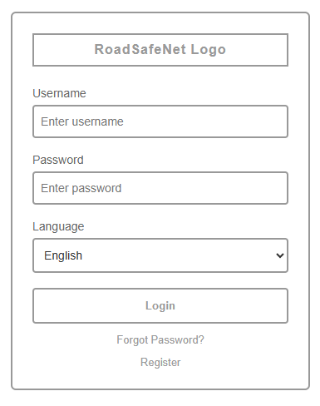
Figure 10 Log in
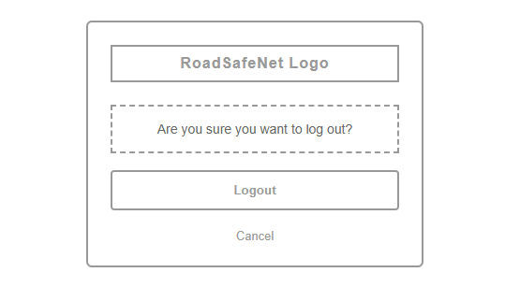
Figure 11 Log Out

Though quite minimal in its visual representation, this wireframe-type of representation presents the functional core of the Login and Logout flows that is focused on clarity, security, and speed, which are the major demands on a real-time emergency response system, such as RoadSafeNet.

- Home Page
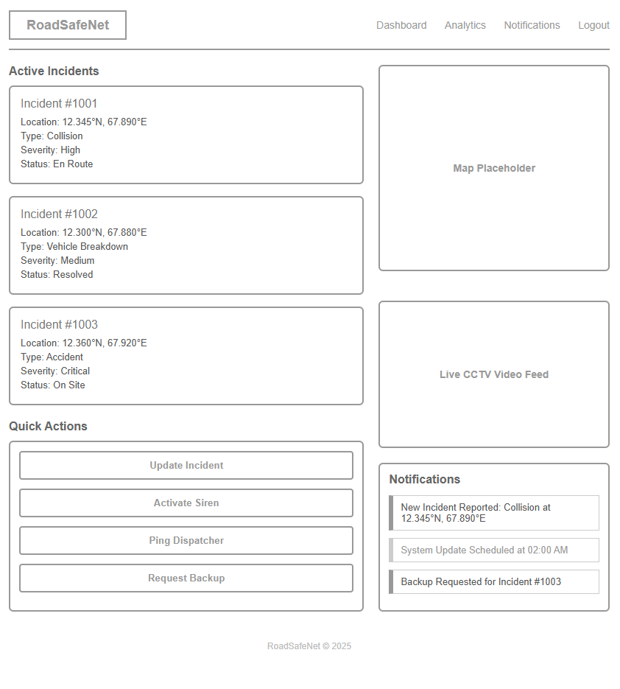
Figure 12 Home Page

The Home Page of RoadSafeNet is the dashboard used most as its format includes basic and necessary data of incidents, live monitoring, and responsive controls in a tidy and wireframe format. It is oriented toward firsthand situational awareness and its efficient realization, as well as convenience toward a variety of user profiles, such as emergency responders, traffic managers, and administrators.

The header shows the RoadSafeNet logo and a leaner menu of navigations to the functions, Dashboard, Analytics, Notifications, and Logout, at the top of the site. This offers a constant orientation and quick interchange with modules of the system without any visual garbage.

The Active Incidents consists of a grid of structured incident cards in the section found on in the left part of the layout design. At the center of each card, there are main fields of the incident number, the coordinates of the locality, the type of incident, the severity, and the status so that the responders could select and scan to sort out. Cards are clickable, and intended to connect with detailed views where responders can update statuses (e.g., En Route, On Site, Resolved) or take additional actions.

Beneath the incident list, Quick Action controls are arranged as a vertical button set. These provide immediate access to high-priority tasks such as:

- Updating incident records

- Activating a siren

- Pinging a dispatcher

- Requesting backup

On the right side, the layout includes three major operational panels:

- Map Placeholder – Listed to be used to embed a geospatial view (e.g. OpenStreetMap) that displays current incidents, available service units and road conditions.
- Live CCTV Video Feed – A dedicated window to display real-time camera feeds from roadside or mobile units to help in quick threat assessment.

- Notification Center – Shows real-time alerts like New Incidents, System Updates and Resource Requests. It is possible to give mark to notifications as read and sort them according to urgency.
The design is not based on color, rather border outlines, typographic hierarchy and spatial grouping are used to indicate sections-not only making it visible even in print-friendly settings but also allowing it to work well with a limited palette.

Such a minimalistic yet highly informative structure guarantees that both in the location of a user (field or control terminal), they can id The Home Page of RoadSafeNet No one can surf it, it is visually clean, and wireframe in its structure: This is the main operational dashboard in which all the necessary information about the incident can be presented, live monitoring tools, and the main controls to react quickly are made available. The design is focused on the immediate situational awareness, the ability to implement tasks efficiently, and roles of different users, including emergency response, traffic management, etc.

- Incident Detail Page

Incident Detail Page within RoadSafeNet offers a single incident management with increased levels of detail access, without distraction, to information, media and controls by responders, coordinators and administrators. Its page design occupies a bordered central panel and is organized as a clear matter with well-constructed stream of content.
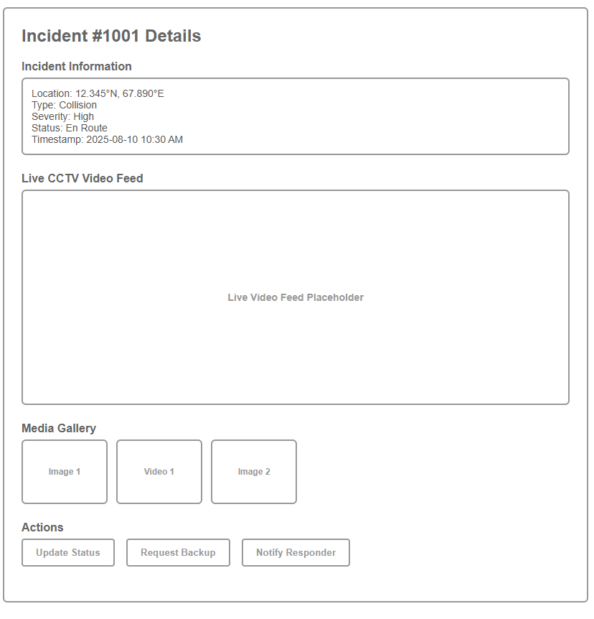
Figure 13 Incident Detail Page
At the top we have the incident header that has in it the specific incident ID which can be easily referenced whenever communicating and within our reports.

The first part Incident Information applies significant operational information in a value box in connection with borders. There are fields whose value is, among others, geographic coordinates, incident type, severity classification, current response status, and time stamp. The systematic arrangement of the display presents an index that can be perused quickly and still have a uniform format of all incident records.
This is followed by the Live CCTV Video Feed block that has a big place marker to add live video feeds to the cameras mounted by the side of the roads or cameras fitted to vehicles. The on-the-spot situational assessment can rely on this feed; therefore, response strategies can be changed according to the real-time situation.

The Media Gallery is made available to get immediate access to the supporting visual evidence, like photographs, video clips or drone images. This is managed by creating thumbnails in a horizontal manner so that operators may view various perspectives prior to opening files on a detailed perspective. This area allows the examination of evidence, documentation of a situation, and the cross-checking.

The final Actions section provides a set of high-priority operational buttons. From here, users can:
- Update Status - Meaning changes the incident’s operational state such as En Route, On Site, Resolved
- Request Backup - The trigger reinforcement requests to dispatch or nearby units.
- Notify Responder - Send targeted alerts or updates to specific team members.
It is based on monochrome outlines, typographic hierarchy and consistent spacing to identify sections and can display the interface in the same manner in print or low bandwidth environments where colour is not available. This design will mean that anyone in control center or on the field will be able to quickly get an overview of the status of an incident, access applicable media and work through decisive steps with minimal navigation.

- Analytics Dashboard Page

Analytics Dashboard RoadSafeNet RoadSafeNet is an Analytics Dashboard to give decision-makers, analysts and operational leaders a clear, data driven perspective on system performance and trends in traffic incidents. Its design is focused on providing prompt data interpretation, dynamic filtering and actionable information that can be used in both strategic planning and response optimization in real-time.
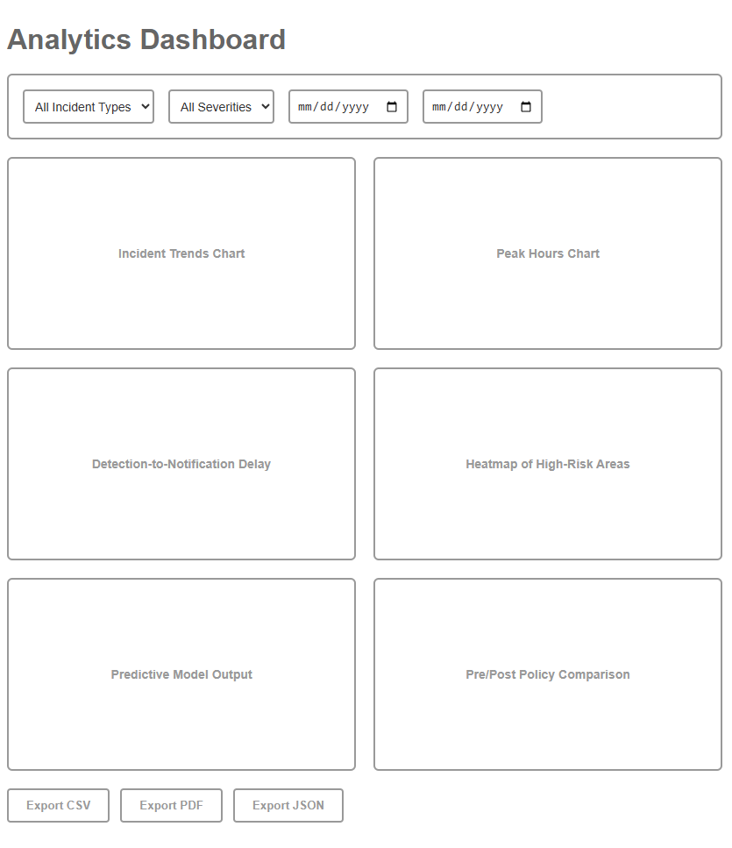
Figure 14 Analytics Dashboard Page
The largest section on the interface is the data filters panel which gives the user control over the output of the analytics by incident type, severity level, and date range. This makes it possible to narrow the analysis, e.g., finding patterns only of high-severity collisions or analyzing the breakdown incidents within a definite period of time. Created filters also ensure responsive results; the visual element of the dashboard is re-rendered without involving unwanted page refresh.

The middle part is a chart grid consisting of modules, each bordered space is a fixed data visualization area:
- Incident Trends Chart - a chart monitoring the quantity and nature of incidents on the regular basis.
- Peak Hours Chart-points out the time slot during which incidents are most occurring.
- Detection-to-Notification Delay- gauges promptness of the system in notification and alert dispatching, after detecting the incident.
- Heatmap of High-Risk Areas - indicates geographical areas of concentrated reports of incidents.
- AI-Driven Forecasts of a possible high-risk period or place of occurrence - the predictive model presents forecasts of risks based on AI analysis.
- Pre/Post Policy Comparison - assesses the effect of safety interventions or law enforcement policy or infrastructure modifications.

It is a responsive grid; flexibly going with various screen sizes but retaining ease of use and aesthetics. The panels are distinct analytical components, and therefore can be expanded or replaced in the future without necessarily requiring a redesign of the whole dashboard.

Below the charts, the export the tools page offers numerous output formats, CSV, PDF, and JSON, which guarantees compatibility with a big variety of reporting, archive, and data integration processes. This allows working with third-party agencies, seamless networking with predictive maintenance systems, or offline documentation. The wireframe focuses on clean notations, black/white placeholders, and ample spacing of text and information to maintain usability on high-performance desktops and low-bandwidth conditions in the field. Analysing the complex values in a convenient visual form, the Analytics Dashboard enables the representatives of the stakeholder group to understand the tendencies, estimate risks, and make decisions promptly.

- Notification Management Page

The RoadSafeNet Notification Management interface is the hub around which multilingual, multi-channel emergency messaging is performed. It allows administrators to design automated communication journeys, personalize messages and measure delivery effectiveness with machine-like precision--making sure time-sensitive information gets the right person, in the right language and in the right channel.

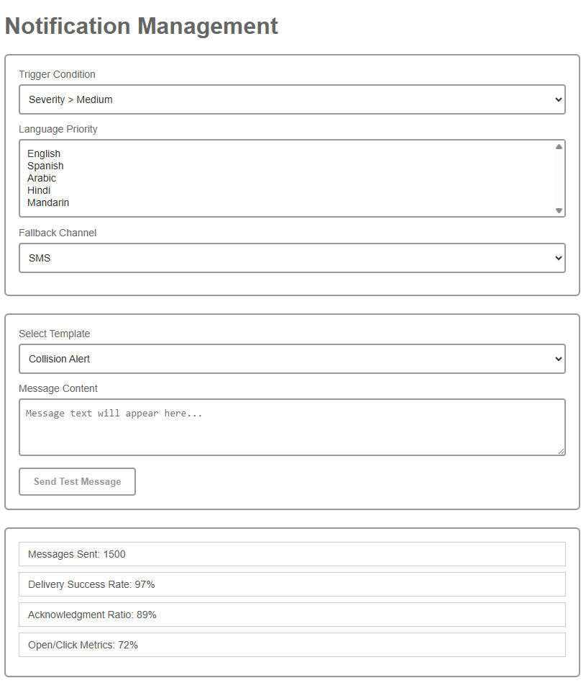
Figure 15 Notification Management Page

The upper one is dedicated to the rule configuration, during which administrators outline the conditions under which triggers should be launched, including -
- Severity over Medium incidents
- The incidents that are located within a radius of 2 km of a responder base
- The general broadcast types of incidents

Supporting environments permit the choice of language priority and back up channels (ex: SMS, Email, Telegram) to ensure that messages are delivered in case a first channel is unavailable. These parameters cause notifications to be location-aware and tolerant to disruptions due to communication.

The Message Template Library facilitates streamlining of alerts creation. The system will have a number of predetermined templates that identify types of incidents, their urgency and channels of their choice. All the templates are editable, allowing them to support multilingual entry of information so that it could make it appealing culturally and be grammatically correct. Although this wireframe contains placeholders that remain static, the production system would be able to support advanced translation mechanisms (e.g., Hugging Face Transformers) and localize text to remove redundancies and fill the gaps without sounding stilted.

The Real-Time Statistics section at the bottom of the page offers visibility of the operations on the basis of the key performance indicators that include,
- Total message sent
- Channel success rates in delivery
- Acknowledgment ratios of responders
- Open and click through engagement tracking metrics

These measures aid in allowing the administrators to determine the effectiveness of communication, diagnose failed deliveries, and improvement areas. To extend this in more detail, the system might provide drill-down capabilities to an individual responder history, retry failed notifications automatically and produce secure exportable logs as a useful aid to audit or incident review.

Flexible automation rules, multilingual messaging support, and actable delivery insights allow to combine the notifications in the Notification Management module that helps make information about emergencies role-sensitive, timely and reliable. It optimizes the speed and accuracy between incident detection and responder action by improving the overall speed, accuracy and reliability of the emergency communications ecosystem at RoadSafeNet.

- User Management Page

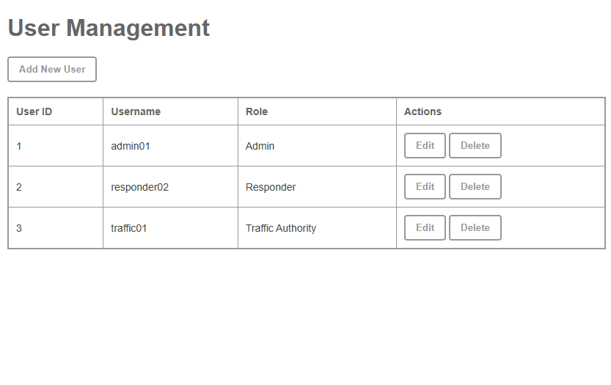
Figure 16 User Management Page

The User Management module gives the administrators complete control over the accounts system and hence they are empowered to create and edit and also delete user profiles at the same time making sure there is a correlation between access privileges and the job requirements. This role is vital in ensuring security, disallowing unauthorized people to use the spaces involved, and in ensuring that the right people handle sensitive parts of the systems.
The Add New User button at the top interface starts the account creation process where the administrator can do all the account creation tasks like assigning username, roles and authenticating settings. They can include roles,

- Admin -All access to modules, system settings, as well as audit logs
- Responder - Viewing of incident alerts and related communication tools and responder-focused analytics

Traffic Authority Access roadway intelligent traffic incident information, reports enforcement and policy review
The main table is a listing of all active user accounts showing:
- User ID: system generated identifier of each account
- Username- Logging name to log in
- Role Defines modules and available permissions
- Actions - Edit (update details, reset passwords, assign different roles) and Delete (delete the account forever)

It has content layouts that are keyboard friendly which makes it inclusive to all users. The pagination, search and filtering might be applied to the large user datasets in a fully implemented system.

This module enhances the security stance of RoadSafeNet by managing the roles and correctly enforcing user life cycle management thus ensuring accountability. It helps in adhering to best practices in access control in the following ways,
- Having a distinct audit trail of user modification
- Allowing swift deactivation of the accounts of personnel who have left the organization
- Role based restrictions against privilege escalation

User Management page is an extremely critical administrative tool that maintains not only the integrity of the operation but also that the correct people have access to the correct access at the correct time.

- System Logs Page

System Logs module is the RoadSafeNet centre of audit and diagnostics, which allows administrators, security officers and technical users to review, trace and analyse system activity. This log repository is paramount in incident forensics, troubleshooting and compliance auditing in a safety important setting.
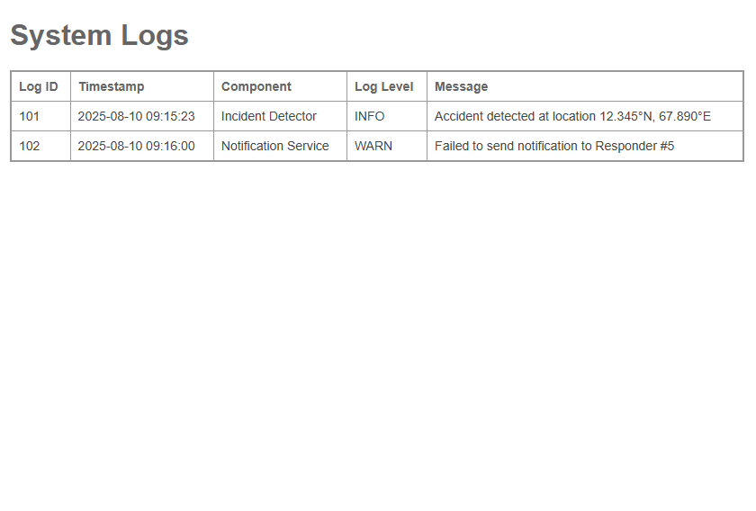
Figure 17 System Logs Page

The interface will display log data in a tabular form with a structured format of the main fields as shown below:
Log ID- The ID to every event recording, easy to cross-reference in the course of investigations.
- Timestamp Precise e-mail date and time (down to the second) a given event took place and would aid in accurate reconstruction of the sequence.
- Component -The RoadSafeNet component/service of the instance that created the log entry (e.g., Incident Detector, Notification Service).
- Log Level - Severity categories on a standardized level (INFO, WARN, ERROR, CRITICAL) to assist in sorting out priorities of review and action.
- Message -A message that has been readable by a human that describes the event with the results of the operations or errors observed.

The log entries are listed chronologically, and can be shown do with hover highlighting to aid readability and concentration. In a complete working installation administrators would be able to -
- Filter logs by component, severity or a date range
- Search by keywords or Log Ids
- Export log in a format to be stored locally or to other SIEM (Security Information and Event Management) systems
- Explore the details of log on a drill-down basis to expose stack traces or other system actions
This page allows:
- Security accreditation (e.g. ISO 27001, NIST SP 800-92 logging guidelines)
- Continuous operation by fast fault identification
- Responsibility through tracing of the activities that were undertaken by robotic services as well as human agents

The System Logs page is an essential part of the reliability strategy in RoadSafeNet; thus, every critical action is monitored, saved and it can be retrieved at any required time, therefore, makes the emergency response operations stronger within the lines of trust, transparency and resilience.

- Settings / Preferences Page

Settings / Preferences module in RoadSafeNet offers the centralized customization interface to the users so that the customization may be provided enabling accessibility, usability, and relevancy among the various user roles and languages. This configuration panel gives the operators, the responders and the administrators the ability to align the platform with their linguistic preferences, with their operational preferences, and with their interface preferences.
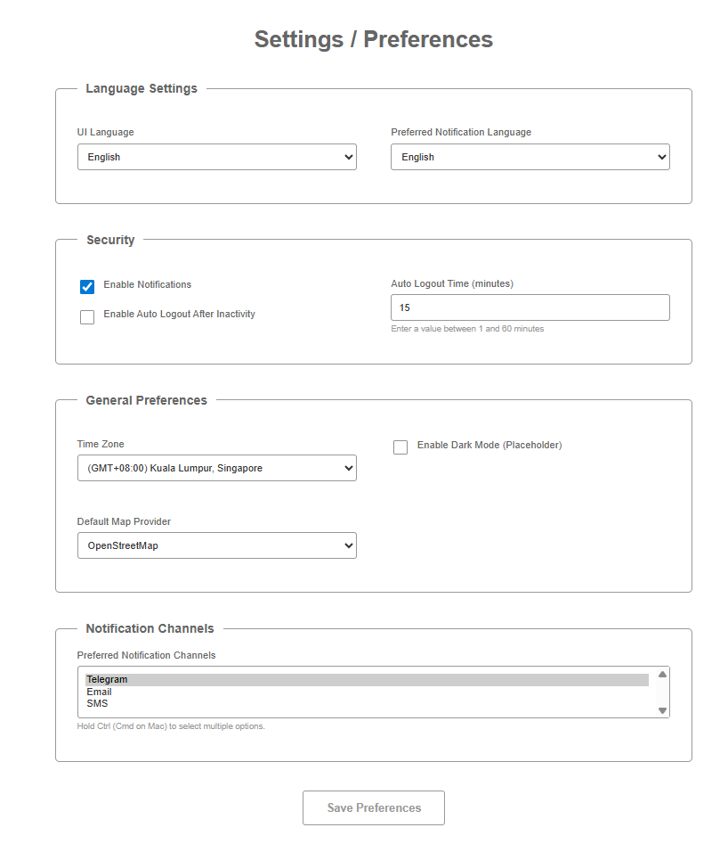
Figure 18 Settings / Preferences Page

Key features include:
- UI Language Selection – A drop-down list that gives user freedom to choose the interface language (i.e. in English, Spanish, Arabic, Hindi, Mandarin). This allows multi-lingual deployment, as well as enhance access in regions with multi-lingual needs.
- Enable Notifications – A button to switch between the real-time notifications of the system. Such a preference enables the user to personalize the notification stream with a choice of a particular role, shift to work, or changing a situation, all without violation of important safety measures.
- Dark Mode (Placeholder) – An option that allows changing the user interface theme which will be implemented in the future and is planned to allow the user to lower the eye strain in cases of low-light conditions and view the screen clearly during the night activities.
- Save Preferences Button – Commits any changes to the user’s profile, ensuring preferences persist across sessions and devices.

The Settings / Preferences page would also in a fully implemented version be integrated with RoadSafeNet authentication system to store user configurations and settings in a centralized database allowing them to be instantly presented (via a JSON request) to any logged-in user via any approved device. Advanced deployments could include:
- Role-specific settings (e.g., other types of alerts that an emergency responder may need; a simplified UI intended to be used by the casual user)
- Simulated notification setting-up according to time
- What units are used to measure regional distances, display items on the map

With its ability to enable custom attached controls, the Settings / Preferences page enhances user interactivity, ease of operation, and readiness of response, and allows the RoadSafeNet application service to be flexible to not only personal preferences but also organizational levels.

3.7 Test Plan
Table 1: Essential Test Cases
Test ID | Test Category | Test Name | Input/Method | Expected Result | Success Criteria | Duration
UT-01 | Unit Testing | Video Processing | 3-5 accident videos | System detects accidents | Detection accuracy ≥ 90% | 2 hours
UT-02 | Unit Testing | Non-Accident Scenarios | 3-5 normal traffic videos | No false alerts | False positive rate < 10% | 2 hours
UT-03 | Unit Testing | Address Conversion | Sample GPS coordinates | Readable address | Successful address retrieval | 1 hour
UT-04 | Unit Testing | Telegram Bot | Test incident data | Message delivery | Message received within 60 seconds | 1 hour
IT-01 | Integration | End-to-End Workflow | Upload accident video | Complete process flow | Workflow completed < 2 minutes | 3 hours
IT-02 | Integration | Database Operations | Incident data entry | Data storage/retrieval | Data correctly stored | 1 hour
FT-01 | Functional | Dashboard | Navigate dashboard | All features work | No broken links/forms | 2 hours
FT-02 | Functional | User Authentication | Valid/invalid credentials | Proper access control | Secure login/logout | 1 hour
FT-03 | Functional | Report Generation | Generate reports | Formatted reports | Reports display correctly | 1 hour
PT-01 | Performance | Detection Speed | Single video processing | Results within time limit | 30-60 second requirement | 2 hours
PT-02 | Performance | Resource Usage | Normal operation | Monitor CPU/memory | System remains responsive | 1 hour
UT-05 | Usability | Multilingual Support | Test language settings | Proper text display | Text displays in 3+ languages | 2 hours
UT-06 | Usability | Mobile Responsiveness | Access on mobile browser | Readable interface | Interface adapts to screens | 1 hour
Table 5 Essential Test Cases

Table 2: Test Environment and Resources

Category | Component | Specification | Purpose
Hardware | Development Machine | Your local laptop | Primary testing environment
Software | Operating System | Windows/Mac/Linux | Base system
 | Web Browser | Chrome, Firefox | Cross-browser testing
 | Database | SQLite | Data storage testing
Network | Connection | Local Wi-Fi | API testing
Test Tools | Manual Testing | Checklists | Systematic verification
 | API Testing | Postman | Endpoint testing
 | Performance | Browser DevTools | Monitoring
 | Communication | Telegram Test Bot | Notification testing
Table 6 Test Environment and Resources

Table 3: Test Data Requirements

Data Type | Quantity | Description | Source
Video Data | 5-7 files | Accident scenario videos | Downloaded/recorded samples
 | 5-7 files | Normal traffic videos | Downloaded/recorded samples
Location Data | 10-15 coordinates | GPS coordinates for testing | Sample locations (urban/rural)
User Data | 3-5 accounts | Test user accounts | Created for testing
Media Files | Various formats | Images and videos | Test media samples
Table 7 Test Data Requirements
Table 4: Test Schedule

Phase | Week | Activities | Deliverables
Phase 1 | Week 1 | Unit Testing (UT-01 to UT-04) | Individual component test results
Phase 2 | Week 2 | Integration & Functional Testing (IT-01, IT-02, FT-01 to FT-03) | Component interaction validation
Phase 3 | Week 3 | Performance & Usability Testing (PT-01, PT-02, UT-05, UT-06) | Complete test documentation
Table 8 Test Schedule

Table 5: Test Documentation Template

Field | Description | Example
Test ID | Unique identifier | UT-01
Test Date | When test was performed | 2025-08-15
Tester | Person conducting test | Your Name
Steps Performed | Detailed test steps | 1. Upload video, 2. Wait for detection...
Actual Result | What actually happened | Detection completed in 45 seconds
Status | Pass/Fail/Pending | PASS
Issues Found | Any problems identified | Minor UI lag during processing
Screenshots | Visual evidence | [Screenshot files]
Table 9 Test Documentation Template

3.8 Chapter Summary
The methodology used in chapter 3 that has discussed in details a methodological framework of developing road safe net has identified a systematic and structured framework of rollout of an innovative road safety web-based application that incorporates the integration of Artificial Intelligence (AI) and Internet of Things (IoT) technology (Sommerville, 2016). The way of working will follow the Agile principles of development and the iterative sprint-based implementation process that enables the system to be flexible enough to tackle the complex nature of coordinating computer vision, geolocation, multilingual communications, and analytics functionalities into one comprehensive emergency response system (Schwaber & Sutherland, 2020).

The analysis of the system was elaborate to trace the key requirements of stakeholders and operational situations, which were used to inform all design choices in the design process (Sharp et al., 2019). The functional requirements include the necessity to use robust accident detection YOLOv10 algorithms, to locate precisely with the help of OpenStreetMap and Nominatim APIs, to provide multilingual emergency notifications that are made possible by Hugging Face Transformers, and to use the full scope of data analysis that helps to manage traffic safety (Ultralytics, 2025; OpenStreetMap Foundation, 2025; Liu et al., 2020). Non-functional requirements are concerned with critical features of emergency systems, i.e., the maximum response time is 30 seconds, the 99.9% uptime of systems, compliance with international accessibility requirements (Web Content Accessibility Guidelines, 2021).

System design was described in the form of use case diagrams, sequence diagrams and class diagram, that all depict modular and scalable architecture. Such design can respond well to immediate emergencies as well as the possibility of making long-term strategic planning improvements on traffic safety (Fowler, 2018; Martin, 2017). The data modeling system gives a firm foundation to store important information and stress on the data integrity, effective storage and retrieval, and other potent analytics that may be used to transform raw occurrence information into a meaningful entity (Silberschatz et al., 2018).

Elaborated by the proposed storyboard, the user interface design is rather simple, accessible, and responsive. It has the requirement to fit the needs of multiple stakeholders, such as emergency response providers, traffic and system administration authorities, and at the same time, it must boast the operational reliability needed in situations where time is of the essence (Nielsen & Landauer, 1993). Their testing strategy that includes unit, integration, performance, security and user acceptance testing also provides high quality assurance framework that assures the reliability of the system and its capability to work in an actual emergency scenario (Myers et al., 2011).

Generally, the system of methodology presented in this chapter provides a clear roadmap that would be followed in the implementation of the system. It will make sure that RoadSafeNet is systematically built in order to address the global road safety problematic areas suggested in Chapter 1 and, at the same time, based on the theoretical and technical framework investigated in Chapter 2 (WHO, 2023). Highly featuring the ideas of open-source interconnection, cost-efficiency, and scalability, the given solution is aimed at being globally applicable (as well as, specifically, to the regions with limited resources) as the WHO is targeting to diminish road traffic fatalities by 50 percent before 2030 (Batty, 2020).

This background sets up the project to be a successful development and deployment project to ensure that RoadSafeNet becomes a valuable contribution to the efforts of the world to improve road safety using technology driven solutions.

REFERENCES
- Apple. (2025). Use Crash Detection on iPhone or Apple Watch to call for help in an accident. https://support.apple.com/en-my/HT213824

- Aslam, M., et al. (2024). An IoT-based automatic vehicle accident detection and visual situation reporting system. Journal of Advanced Transportation, 2024, Article 1059872. https://doi.org/10.1155/2024/1059872

- Batty, M. (2020). Smart cities: Big data, civic hackers, and the quest for a new utopia. Urban Studies, 57(3), 678–683. https://doi.org/10.1177/0042098019876543

- Chen, C., et al. (2022). Deep learning for autonomous driving: A survey. IEEE Transactions on Intelligent Transportation Systems, 23(7), 7293–7312. https://doi.org/10.1109/TITS.2021.3050364

- Consumer Reports. (2024). Cars that come with free automatic crash notification—and those that don’t. https://www.consumerreports.org

- EmergEye. (2024). EmergEye: Real-time emergency response. https://www.emergeye.com

- European Commission. (2023). eCall: Time saved = lives saved. https://transport.ec.europa.eu/transport-themes/intelligent-transport-systems/road/action-plan-and-directive/ecall-time-saved-lives-saved_en

- Fasano, M., et al. (2021). Urban traffic management and emergency response optimization. Transportation Research Part C: Emerging Technologies, 129, 103245. https://doi.org/10.1016/j.trc.2021.103245

- Ganasekara, S., & Fernando, R. (2023). Urban-rural disparities in emergency response systems. Asian Journal of Public Health, 10(2), 88–102.

- Goodfellow, I., Bengio, Y., & Courville, A. (2016). Deep learning. MIT Press.

- Liu, Y., et al. (2020). Multilingual denoising pre-training for neural machine translation. Transactions of the Association for Computational Linguistics, 8, 726–742. https://doi.org/10.1162/tacl_a_00343

- National Highway Traffic Safety Administration. (2023). Traffic safety facts: 2021 data. https://crashstats.nhtsa.dot.gov

- OnStar. (2025). OnStar Automatic Crash Response. https://www.onstar.com/us/en/services/automatic-crash-response

- OpenStreetMap Foundation. (2025). Nominatim API documentation. https://nominatim.org/release-docs/latest/

- Peden, M., et al. (2004). World report on road traffic injury prevention. World Health Organization. https://www.who.int/publications/i/item/world-report-on-road-traffic-injury-prevention

- Perera, K., & Jayawardena, L. (2024). Road safety challenges: A review. Journal of Transport Studies, 12(1), 1–15.
- Plotly. (2023). Plotly Dash documentation. https://dash.plotly.com

- Prisma. (2025). Prisma ORM documentation. https://www.prisma.io/docs/

- Scolese, J., et al. (2020). Rural emergency medical services: Challenges and opportunities. Journal of Rural Health, 36(2), 149–157. https://doi.org/10.1111/jrh.12345

- Ultralytics. (2025). YOLOv10 documentation. https://docs.ultralytics.com

- UN-Habitat. (2022). World cities report 2022: Envisaging the future of cities. https://unhabitat.org/world-cities-report-2022

- World Health Organization. (2023). Road traffic injuries. https://www.who.int/news-room/fact-sheets/detail/road-traffic-injuries

- Zanella, A., et al. (2014). Internet of Things for smart cities. IEEE Internet of Things Journal, 1(1), 22–32. https://doi.org/10.1109/JIOT.2014.2306328

- Apple. (2025). Crash Detection Feature. https://www.apple.com/iphone/crash-detection/

- Aslam, S., Perera, S., & Jayawardena, C. (2024). Realtime road safety: A web and mobile application approach to mitigating animal-vehicle conflicts in Sri Lanka.https://www.ijisrt.com/realtime-road-safety-a-web-and-mobile-application-approach-to-mitigating-animalvehicle-conflicts-in-sri-lanka

- Batty, M. (2020). Global Road Safety Performance Targets. World Health Organization.https://cdn.who.int/media/docs/defaultsource/documents/healthtopics/road-traffic-injuries/12globalroadsafetytargets.pdf

- Choi, S., Lee, J., & Kim, H. (2021). Deep learning applied to road accident detection with transfer learning. Data in Brief, 39, 107678. https://www.sciencedirect.com/science/article/pii/S2352146522006263

- Dolhpolov, A., Lee, J., & Kim, H. (2024). Crash Detecting System Using Deep Learning. California State University, San Bernardino. https://scholarworks.lib.csusb.edu/etd/3138

- EmergEye. (2024). Computer Vision for Citywide Accident Detection. https://emergeye.berkeley.edu/

- European Commission. (2023). eCall: Automated Emergency Call for Vehicles.https://transport.ec.europa.eu/transport-themes/its/road/action-plan/ecall_en

- Fasano, G., Ahmad, A., & Rahman, A. (2021). Malaysia Road Safety Plan 2022-2030. Ministry of Transport Malaysia. https://www.mot.gov.my/en/Pages/Land/Safety%20and%20Security/MRSP%202022-2030%20(1022).pdf

- Ganasekara, K., & Fernando, T. (2023). Multilingual emergency notification using AI .https://www.sciencedirect.com/science/article/pii/S2352146522006263

- Labellerr. (2025). Enhancing Data Annotation Efficiency with YOLOv10. https://www.labellerr.com/blog/enhancing-data-annotation-efficiency-with-yolov10/

- Li, X., Liu, Y., & Wang, X. (2017). Review of image processing approaches for accident detection. International Journal of Creative Research Thoughts, 5(4), 2320–2882. https://www.ijcrt.org/papers/IJCRT2406218.pdf

- Liu, Y., Li, X., & Wang, X. (2012). SVM-based accident detection. International Journal of Creative Research Thoughts, 5(4), 2320–2882. https://www.ijcrt.org/papers/IJCRT2406218.pdf

- OnStar. (2025). Crash Detection and Emergency Response. https://www.onstar.com/us/en/technology/crash-detection/

- OpenStreetMap Foundation. (2025). Nominatim API Documentation. https://nominatim.org/release-docs/latest/

- Perera, S., & Jayawardena, C. (2024). Literature review on road safety technology. https://www.ijisrt.com/realtime-road-safety-a-web-and-mobile-application-approach-to-mitigating-animalvehicle-conflicts-in-sri-lanka

- Plotly. (2023). Plotly Python Graphing Library. https://plotly.com/python/

- Prisma. (2025). Prisma ORM Documentation. https://www.prisma.io/docs/

- Ultralytics. (2025). YOLOv10 Technical Documentation. https://docs.ultralytics.com/compare/yolox-vs-yolov10/

- World Health Organization. (2023). Global status report on road safety 2023. https://www.who.int/teams/social-determinants-of-health/safety-and-mobility/global-status-report-on-road-safety-2023

- Zanella, A., Bui, N., Castellani, A., Vangelista, L., & Zorzi, M. (2014). Drones for road accident management: A systematic review. https://eprints.utm.my/104902/1/AnuarAhmad2023_DronesforRoadAccidentManagement.pdf

- Batty, M. (2020). The World Health Organization's Decade of Action for Road Safety 2021–2030. WHO Publications.

- Fowler, M. (2018). Refactoring: Improving the Design of Existing Code, 2nd Edition. Addison-Wesley.Available at: https://martinfowler.com/books/refactoring.html and https://www.booktopia.com.au/refactoring-2ed-martin fowler/book/9780134757599.html

- Liu, Y., Gu, J., Goyal, N., Li, X., Edunov, S., Ghazvininejad, M., Lewis, M., & Zettlemoyer, L. (2020). Multilingual Denoising Pre-training for Neural Machine Translation. Hugging Face.Available at: https://huggingface.co/facebook/convnext-large-224 and https://arxiv.org/pdf/2306.16891.pdf

- Martin, R. C. (2017). Clean Architecture: A Craftsman's Guide to Software Structure and Design. Prentice Hall.

- Myers, G. J., Sandler, C., & Badgett, T. (2011). The Art of Software Testing, 3rd Edition. Wiley.

- Nielsen, J., & Landauer, T. K. (1993). A Mathematical Model of the Finding of Usability Problems. CHI '93 Proceedings.

- OpenStreetMap Foundation (2025). OpenStreetMap Services and APIs. Available at: https://www.openstreetmap.org and https://wiki.openstreetmap.org/wiki/API_v0.6

- Schwaber, K. & Sutherland, J. (2020). The Scrum Guide 2020. Scrum.org.
Available at: https://www.scruminc.com/2020-scrum-guide-changes-updates-explained/ and https://www.infoq.com/articles/changes-2020-Scrum-guide/

- Sharp, H., Preece, J., & Rogers, Y. (2019). Interaction Design: Beyond Human-Computer Interaction. Wiley.Available at: https://books.google.com/books/about/Interaction_Design.html?id=HreODwAAQBAJ and
https://digilib.stiestekom.ac.id/assets/dokumen/ebook/feb_d2da2b2ae5541cebf7e87884e0a46b395eaff87a_1659872033.pdf

- Silberschatz, A., Galvin, P. B., & Gagne, G. (2018). Operating System Concepts, 10th Edition. Wiley.

- Sommerville, I. (2016). Software Engineering, 10th Edition. Pearson Education.Available at: https://www.pearson.com/en-us/subject-catalog/p/software-engineering/P200000003258/9780137503148, https://dn790001.ca.archive.org/0/items/bme-vik-konyvek/Software%20Engineering%20-%20Ian%20Sommerville.pdf, and https://software-engineering-book.com

- Ultralytics (2025). YOLOv10: Real-Time End-to-End Object Detection.
Available at: https://docs.ultralytics.com/compare/yolox-vs-yolov10/ and https://docs.ultralytics.com/compare/yolov10-vs-pp-yoloe/

- Web Content Accessibility Guidelines (2021). WCAG 2.1 W3C Recommendation.Available at: https://www.w3.org/TR/WCAG21/ and https://www.ada.gov/resources/2024-03-08-web-rule/

- WHO (2023). Global Status Report on Road Safety 2023. World Health Organization.

